Internship report Jordy van Maenen

Table of Contents

Assignment 1: Smart Meter 4

1. Research 4

1.1 General: 4

1.2 Connector: 4

1.3 Signal P1 port 5

1.4 Signal converter 6

1.5 power supply 7

1.6 MCU 7

1.7 Software 8

1.8 Requirements 9

2. Choices 11

2.1 Connector 11

2.2 Signal converter 11

2.3 Power supply 12

2.4 MCU-module 13

2.5 Whether or not an external power supply is required 13

2.6 LED’s 14

3. The design 15

3.1 Component Selection 15

3.2 Unit design 17

3.2.1 RJ12 connector 17

3.2.2 Power supply switch 17

3.2.3 Signal converter 19

3.2.4 Power supply 21

3.2.5 MCU 21

3.2.6 LED’s 23

3.2.7 Other 27

4. Unit tests 28

4.1 RJ12 connector 28

4.1.1 RJ12 connector test 28

4.1.2 Test result RJ12 connector 28

4.2 Power supply switch 28

4.2.1 Power supply switch test 28

4.2.2 Test result power supply switch 29

4.3 Signal converter 31

4.3.1 Signal converter test 31

4.2.2 Test result signal converter 32

4.4 Voltage converter 33

4.4.1 Voltage converter test 33

4.4.2 Test result voltage converter 34

5. Integration test 35

5.1 Units power supply switch and unit voltage converter 35

5.1.1 Test units power supply switch and voltage converter 35

5.1.2 Test result units power supply switch and voltage converter 35

5.2 Units LED’s, power supply switch and voltage converter 35

5.2.1 Test units LED’s, power supply switch and voltage converter 35

5.2.2 Test result units LED’s, power supply switch and voltage converter 36

6. PCB-design 39

7. Acceptance test 42

7.1 Test 1: 42

7.1.1 Execution test 1: 42

7.1.2 Result test 1 43

7.2 Test 2: 44

7.2.1 Execution test 2: 44

7.2.2 Result test 2: 45

7.3 Test 3: 47

7.3.1 Execution test 3: 47

7.3.2 Result test 3: 49

7.4.1 Execution test 4: 52

7.4.2 Result test 4: 54

Bibliography 57

# Assignment 1: Smart Meter

# Research

## 1.1 General:

Crownstone's first assignment is to design a product that can be connected (and powered) using the P1 port of a smart meter. A plug of the RJ11 6P4C or 6P6C type can be inserted into the P1 port of a smart meter. Pin 1 of this port has +5V and pin 6 is the power_GND pin. The power supply can supply a current of up to 250mA continuously when the smart meter is based on DSMR (Dutch Smart Meter Requirements) 5 or higher [1]. When the smart meter is based on DSMR 4 or older, a maximum of 100mA can be used continuously [2]. With DSMR 2, no power from the P1 port can be used at all. Exact numbers are not available, but DSMR 5 seems to be the most used standard at the moment followed by DSMR 4 and DSMR 2. DSMR 5 and 4 are very similar in that they use the same baud rate, a start bit, 8 data bits, no parity bit and a stop bit. However, there are several differences when it comes to the frequency with which the different standards send their information. DSMR 5 only sends all data every second and then sends measurements of gas consumption, thermal consumption and water consumption for the last 5 minutes. DSMR 4 sends all data every 10 minutes and then sends the last hour measurement of gas consumption, thermal consumption and water consumption. DSMR 2 transmits all data every hour. The smart meter uses an open collector output to send the data. This means that the output is either floating or connected to GND. To make a good signal, a pull-up resistor is needed.

## 1.2 Connector:

To use this port, a plug of the RJ11 6P4C or 6P6C type must be inserted. For this project the RJ11 6P6C connector (also called the RJ12 connector) is chosen. This connector has 2 pins more than the standard RJ11 connector, these pins enable using the power from the P1 port.

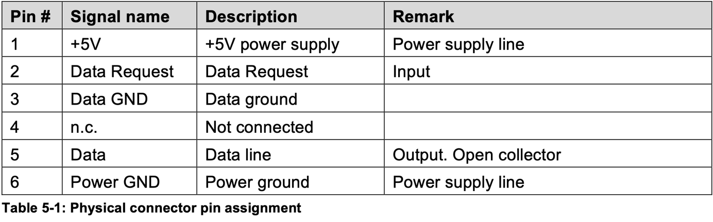

Figure 1

Figure 1 shows the pinout of the RJ12 connector, this table can be found in the datasheets of DSMR 4 [2] and 5 [1] on page 6. A maximum of 5mA may run into the data pin. The supply voltage from the P1 port may be a maximum of 5.5V, to realize a maximum current of 5mA a resistance value of at least 5.5/5mA = 1100Ω is required. The data line probably does not need to be able to supply 5mA for the rest of the circuit to function, therefor it is useful to use a higher pull-up resistor to reduce losses. To start the data transfer, a voltage between 4V and 5.5V must be applied to the request pin.

## 1.3 Signal P1 port

For the design and selection of a suitable converter, it is also useful to know the maximum switching speed of the signal from the P1 port. This can be investigated with a simple circuit consisting of a male RJ12 connector, a 6-core flat cable, a pull-up resistor and a prototype board.

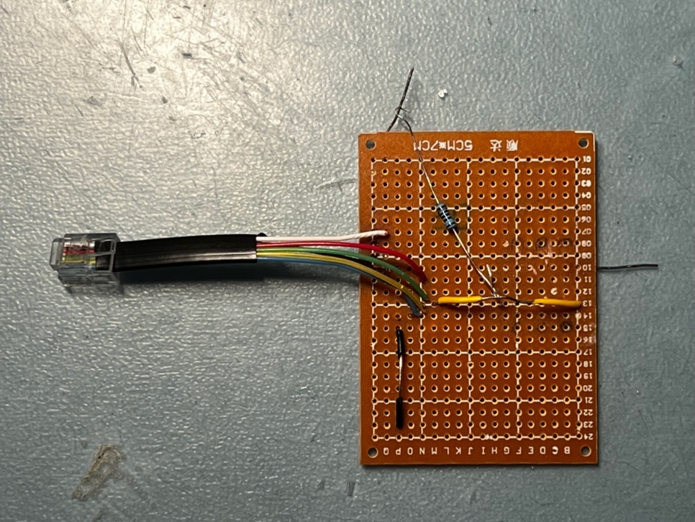

Figure 2

Figure 2 shows the designed test board. The top stripped wire and the stripped wire on the right side must be connected to each other start the data transfer from the P1 port. The yellow center stripped wire is the measurement point for data pin 5. The black center stripped wire is the GND point. This test board can be plugged directly into the P1 port of a smart meter. In this test, it was inserted into a DSMR 5.0 meter to investigate the minimum pulse duration. Then the probe of the oscilloscope is connected to the yellow wire and the GND point to the black wire. The oscilloscope is turned on and the two completely stripped wires are connected to each other. This made the signal from the P1 port clearly visible on the oscilloscope.

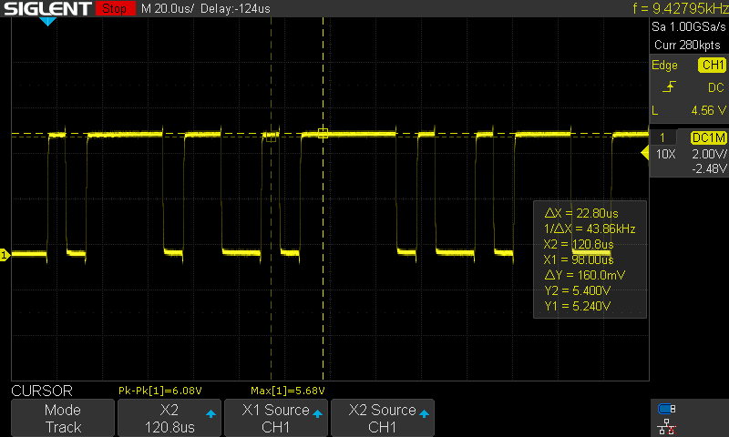

Figure 3

Figure 3 shows the signal measured from the half stripped yellow wire, this is the signal from the P1 port. This measurement will be useful in the design phase.

## 1.4 Signal converter

The signal from the data pin is an inverted, too high, but otherwise a UART signal readable by a microcontroller. In this case, a high voltage (>1V, max 15V) is a 0 and a low voltage (<1V) is a 1. To make this signal readable for the microcontroller, it must be inverted and reduced to a maximum of 3.3V.

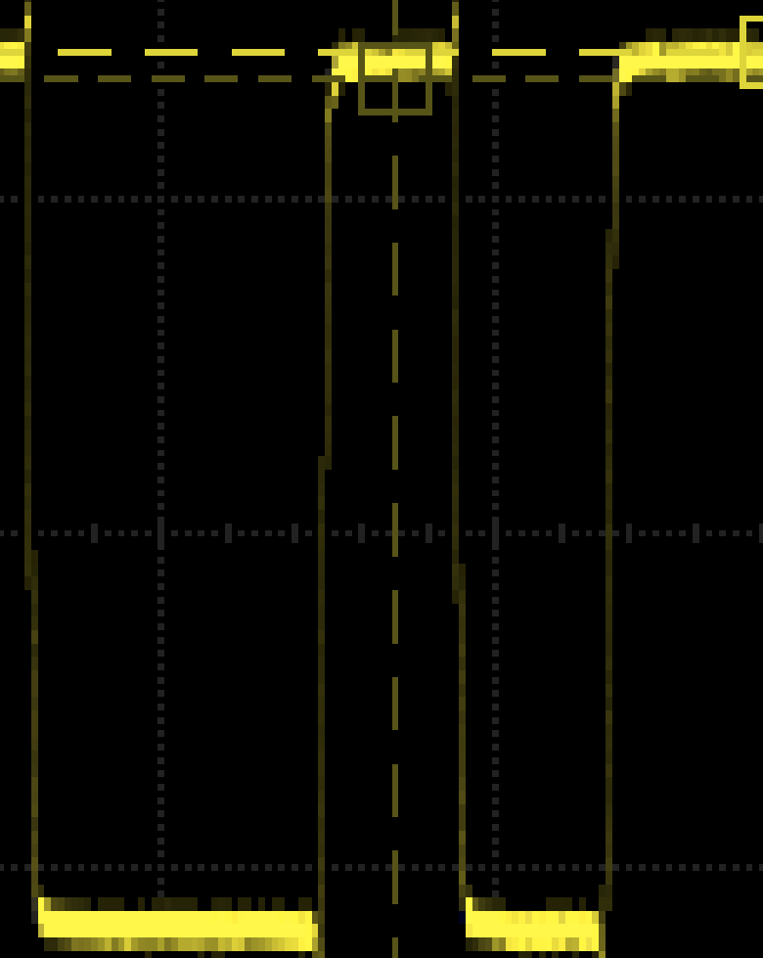

Figure 4

Figure 4 is a zoomed in view of the smallest pulse duration from Figure 3. This pulse lasts approximately 7.6µs. To choose a suitable converter, it is important that it is fast enough to display the signal properly. To determine which slew rate is needed to get a signal of which a maximum of $\frac{1}{3}$ is used for the rise and fall time, the following calculations are needed:

$$\frac{7.6us}{6}= 1.26µs maximum rise time$$

$$\frac{3.3v}{1.26us}=2.62v/{µs} minimum slew rate$$

Thus, a minimum slew rate of $2.62 v/{µs}$ is required to maintain a clear signal. This must be considered when selecting the signal converter.

## 1.5 power supply

The supply voltage from the P1 port can be a maximum of 5.5V and a minimum of 4V, generally this voltage is 5V. With the test board in Figure 2 it is also possible to measure the exact supply voltage of the tested smart meter.

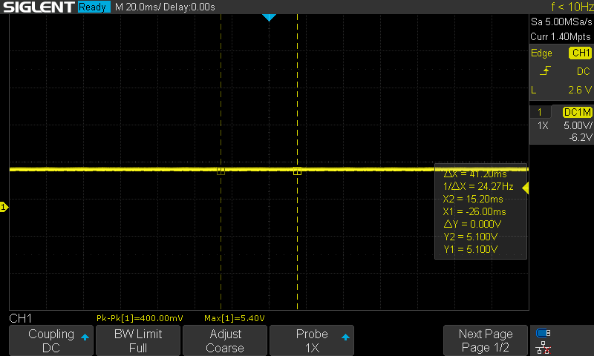

Figure 5

Figure 5 shows this measurement. The maximum measured voltage can be seen at the bottom, this is 5.4V. This is probably a very short peak due to an outside disturbance. Y2 and Y1 can be read in the cursor box on the right of the image. These are the measured voltages on the cursors, both are 5.1V. This measurement shows that the actual voltage is very close to the expected 5V.

## 1.6 MCU

There are two options for the microcontroller unit, a ready-made module or a custom designed circuit with a separate NRF52832 chip. A ready-made module has the advantage that it is easy to implement, already approved and easy to update when a better module becomes available. The advantage of a self-designed circuit is that it can be made smaller than a ready-made module and that it can be fully adapted to the requirements of the product. In addition, the component costs are lower than for a ready-made module, but the design costs are higher. Whichever of the two options is chosen, several things must be considered during the design. For example, the design requires a 32MHz oscillator and 32KHz oscillator. These are both used for timing in the current Crownstone product, it is therefore convenient to use them in this design as well. Furthermore, decoupling capacitors should also be considered. These ensure that the supply voltage is equalized so that the microcontroller does not skip instructions or behave in any other unexpected way.

## 1.7 Software

Good software is also needed to process the information. Ideally, the product should be able to work with all smart meters in use. This would make the product more attractive to potential customers because there is no need to consider whether the device is suitable for the used smart meter. This does create some difficulties. As described earlier, the different standards are different from each other. With a DSMR 2 smart meter it is not possible to power external devices through the P1 port. Because of this a solution must be found to power the product with an external power supply, otherwise DSMR 2 meters won’t be supported by the product. In addition, it must be made possible in software to change the serial settings automatically while the program is running. This would make it possible to read the information from DSMR 2 meters. Furthermore, the program must also be able to recognize reference numbers. These reference numbers indicate what the data that come after means. All these reference numbers can be found in the DMSR 4 datasheet [2] and DSMR 5 datasheet [1]. The reference numbers given in the datasheet are all reference numbers, not every smart meter uses them all. Because of this, the program should also be able to skip numbers when they are not given. For example, a single-phase smart meter will not provide information about phases other than the one it is connected to.

## 1.8 Requirements

For convenience, “the fully assembled board with the final software” will hereinafter be referred to as the “product”.

Functional requirements:

* REQ-1: The product must be able to be connected to the P1 port of a smart meter.
* REQ-2: The product must be able to receive power through the P1 port of a smart meter.
* REQ-3: The current power and gas consumption data should be sent via Bluetooth as soon as it is received from the P1 port.
* REQ-4: The product may use a maximum current of 100mA.
* REQ-5: The consumption of several phases (if present) must be sent individually, the total consumption can then be easily calculated on a connected device.
* REQ-6: A timestamp is sent at the beginning of the message from the P1 port. This must be sent by the product.
* REQ-7: The product must be able to work with smart meters based on Dutch Smart Meter Requirements (DSMR) 5, 4 and 2.

Non-functional requirements:

* REQ-8: The NRF52832 from Nordic Semi must be used in the product.
* REQ-9: The product must be produced as cost effective as possible without affecting other requirements.
* REQ-10: The product must be made as small as possible without limiting functionality.
* REQ-11: The product must be programmable via the SWD pins.
* REQ-12: It must be possible to debug the product via UART.

Further explanation:

* REQ-1: To ensure that the product can communicate with the smart meter, it must be possible to connect the device to the smart meter. This is only possible by using the P1 port of the smart meter.
* REQ-2: Smart meters using DSMR 4 or higher can power external devices through the P1 port. Using this function simplifies the installation of the product for the customer.
* REQ-3: Crownstone uses Bluetooth in all its products and this product must also work with Bluetooth so that it can be integrated with other Crownstone products. The power and gas consumption data are the most interesting in the beginning, this already provides a good insight into the energy consumption. Additional information such as district heating and cooling or water use can be added later in software.
* REQ-4: Crownstone is already working with chips from Nordic Semi and the nRF52832, among others. It is therefore convenient for the company that this product also contains this chip so that the firmware of this product can be integrated with the Bluenet firmware from Crownstone itself. This firmware can be found at <https://github.com/crownstone/bluenet>.
* REQ-5: DSMR 5 and above can handle up to 250mA but in this case the current consumption must remain below 100mA to ensure that the product also works with smart meters based on DSMR 4 without the need to connect an external power supply.
* REQ-6: Viewing the consumption of individual phases can be very interesting for a user. For example, perhaps the different phases are used for different parts of a building, here the consumption of the different parts of the building could be monitored.
* REQ-7: It is useful to send the timestamp from the P1 port so that the measured energy consumption can be displayed at the correct time.
* REQ-8: It is useful to be able to make the product work on almost all smart meters in the Netherlands. As a result, potential customers do not have to think about whether the product works on their smart meter.
* REQ-9: When making this product, the costs must be considered. It is not the intention that materials are recklessly purchased while perhaps with a little thought a cheaper alternative can be found.
* REQ-10: It is convenient for the user to make this product as small as possible. This would make it easier to place the product in tight spaces.
* REQ-11: The SWD pins on the nRF52832 are there to program the nRF52832. These must be readily available for programming the nRF52832.
* REQ-12: UART is used by Crownstone for debugging. It is useful to also add this function to the product so that as little as possible needs to be changed in the current way of programming.

# Choices

To get this product working, several subsystems are needed. A connector, an inverter, a power supply and an MCU module. In addition, other choices must be made that influence the functioning of the product.

## 2.1 Connector

The product must be able to be connected to a smart meter, this is done with an RJ12 (RJ11 6p6c) connector. One option is to provide the product with an RJ12 port so that a male RJ12 to male RJ12 cable can be used. Another option is to solder a cable with a male RJ12 plug on one side to the product on the other side. This would make that the product a lot flatter. This option has the disadvantage of higher production costs and that if the cable breaks, the entire product no longer works.

|  |  |  |
| --- | --- | --- |
| Solution | Advantages | Disadvantages |
| Solder RJ12 port on PCB | Inexpensive, prevents the product from becoming unusable | Makes the design a lot bigger |
| Solder RJ12 cable on PCB | Small design | Expensive, difficult assembly |

Figure 6

Conclusion:

In this design the RJ12 port on the PCB will be used. Despite the large connector, the design will remain small.

## 2.2 Signal converter

A converter is needed to make the inverted UART signal readable by the microcontroller. A converter can be made in multiple ways. One way is with an opamp. The signal can be inverted by connecting the signal to the negative input, the positive input to 1.65V, the positive power input to 3.3V and the negative input to GND. The 1.65V will be achieved by using two 1MΩ resisters as a voltage divider at the 3.3V. This will cause the output of the opamp to be GND when the signal voltage rises above the 1.65V and be 3.3V when the signal voltage drops below 1.65V. Figure 7 shows another way of inverting a signal by using a transistor circuit. The advantage of using this BJT circuit is that it requires just one transistor and some resistors. The disadvantage is that it requires a current even with ideal components. The BJT circuit uses simpler components but requires more tuning and testing then the opamp circuit to optimize the current consumption.

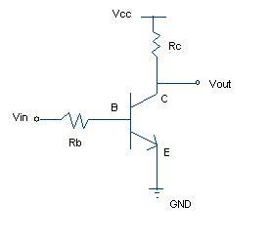

Figure 7

|  |  |  |
| --- | --- | --- |
| Solution | Advantages | Disadvantages |
| Opamp | Easier to implement. In theory lower power consumption. | More expensive |
| Transistor and resistors | Cheap | More finetuning. More components to solder. |

Figure 8

Conclusion:

The choice was made to use an opamp in the design. Here convenience and accuracy are more important than the lowest price.

## 2.3 Power supply

A power supply ensures that the voltage entering the product is made suitable for use by the individual components. There are several options available for this, an LDO or a switching power supply. An LDO has the advantage that it is very simple to implement, especially when an LDO with a fixed output voltage is chosen. The disadvantage of an LDO is that more power is wasted in the form of heat than with a switching power supply. A switching power supply has the advantage that it is more efficient. Disadvantages of a switching power supply are that it causes more noise, is more difficult to implement and is more expensive.

|  |  |  |
| --- | --- | --- |
| Solution | Advantages | Disadvantages |
| LDO | Easy to implement and cheap. | Less efficient |
| Switching power supply | Energy efficient | More expensive, more components, more noise. |

Figure 9

Conclusion:

It was decided to use an LDO in the design. These are less efficient, only the power consumption of the entire design will be minimal, so also the waste.

## 2.4 MCU-module

The MCU module is necessary to process and respond to all incoming information. This module must be programmable so that custom software can be put on it. The NRF52832 is used as the microcontroller. There are different ways to implement this microcontroller, this can be in the form of a ready-made module or a self-designed module. The advantage of a ready-made module is that they are easy to implement and easy to replace if another microcontroller wants to be used. The advantage of a self-designed module is that the costs of the components are lower and that the circuit on the custom PCB can be made very small.

|  |  |  |
| --- | --- | --- |
| Solution | Advantages | Disadvantages |
| Ready-made module | Easy to implement, easy to upgrade. | The price of the component is higher than the individual components of a self-designed module. |
| Self-designed module | Can be made very small, cheaper in production. | Designing is difficult, time consuming and therefore expensive. When a new microcontroller comes out, the entire PCB has to be redesigned. |

Figure 10

Conclusion:

It was decided to use a ready-made module in the design. The purchase costs are ultimately overshadowed by the design costs of a self-designed module.

## 2.5 Whether or not an external power supply is required

According to the requirements drawn up first, the product must in any case be able to be powered from the P1 port. After further investigation, it was discovered that older smart meters do not have the ability to power external equipment via the P1 port. These older smart meters are no longer installed but are still in use. An exact number of old smart meters currently in use has not yet been obtained. If the design does not include the option to power the product via, for example, a micro-USB port, then the older smart meters of DSMR version 2 or lower will not be supported.

|  |  |  |
| --- | --- | --- |
| Solution | Advantages | Disadvantages |
| No external power supply possibility | Easy to design, cheaper in production and development. | The product will not work on older smart meters, then it will work on fewer smart meters than the competition. |
| An external power supply possibility | The consumer does not have to think about what kind of smart meter is installed. | Higher implementation costs, higher production costs. |

Figure 11

Conclusion:

It was decided to add the option to power the product externally. This means that the consumer does not have to think about whether this product works in his or her specific situation. If this were not possible, there would be an extra reason to choose a competing product.

## 2.6 LED’s

LEDs are very useful for providing visual indicators to the user. Different colors can be used to indicate, for example, that the product is on and that there is data transfer. There are just different ways to implement LEDs. There can be chosen to connect individual LEDs directly to the power supply and data line and only control with the microcontroller whether the LEDs respond to these voltages or not. Another option is to connect an RGB LED to the microcontroller and provide status indicators by software. The first option has the advantage that it is very easy to implement, the only disadvantage is that these LEDs cannot be given another function later on. The last option has the advantage that the function of the LEDs can be changed later, the disadvantage is that a little more code is needed for the LEDs to function.

|  |  |  |
| --- | --- | --- |
| Solution | Advantages | Disadvantages |
| Separate LEDs directly on signal lines | Easier to design, cheaper to manufacture, minimum amount of code required. | The LEDs have only one function which cannot be changed later. |
| Control RGB LED with microcontroller | Adjust the functions of the LEDs by software when desired. | More code is needed. |

Figure 12

Conclusion:

It was decided to connect an RGB LED to the microcontroller using Mosfets. It is slightly more difficult to develop, but it does bring many more possibilities with it.

# 3. The design

## 3.1 Component Selection

|  |  |  |  |
| --- | --- | --- | --- |
| Part | Components | Differences | Pick |
| RJ12 connector | 1. Molex 95501-6669 [3] 2. Wurt Elektronik 615006138421 [4] | Option 1 is more available and more compact than option 2. | It was decided to use option 1 in the final design. |
| Opamp | 1. TI TLV9101IDBVR [5] | Option 1 has a rail-to-rail input and output and a slew rate of 4.5V/µs. | It was decided to use option 1 in the final design. This opamp came up as the cheapest and best after applying all search filters, so the choice was immediately clear. |
| LDO | 1. TI TPS7A2533DRVR [6] 2. ST LDFM33PVR [7] 3. MT MCP1755S-3302E/MC [8] | Option 1 has the lowest quiescent current of only 2µA, is the second cheapest per 1000 pieces, but the most expensive in small quantities. Option 2 is the cheapest per 1000 pieces and the second cheapest in small quantities, it only has the highest quiescent current of 200µA. Option 3 is the cheapest in small quantities but the most expensive per 1000 pieces, it is in between the other two in terms of quiescent current with 68µA | It was decided to use option 1 in the final design. The low quiescent current is very nice because it limits additional power wastage. |
| MCU-module | 1. Raytac MDBT42Q-512KV2 [9] 2. Aconno ACN52832 [10] | Option 1 was a very good option because this module was readily available and has a small footprint. Unfortunately, this module is currently difficult to obtain. Option 2 is a slightly larger module. This module is still available and has an extra 32kHz oscillator which therefore does not have to be placed separately on the PCB. | It was decided to use option 2. This module is currently a lot better available. |

Figure 13

* For the female RJ12 connector, the Molex 95501-6669 connector has been chosen. This connector is available from stock and is mostly SMD. This allows more components to be placed at the bottom if necessary.
* The TLV9101IDBVR from TI has been chosen for the opamp used as the converter. This is a low power rail-to-rail opamp, this means that the output is as close to 3.3V or GND as possible.
* For the power supply, the TPS7A2533DRVR from TI has been chosen. This LDO has an Ultra-low quiescent current of 2 μA and a maximum dropout voltage of less than 340 mV at 300 mA, making it a very efficient LDO. This LDO also provides standard 3.3V without the need for external resistors. This saves space on the PCB and cannot change the voltage due to temperature-changing resistors.
* For the MCU module, an ACN52832 from Oconno was chosen. This module is readily available and easy to implement. All pins are on the outside which makes soldering and debugging a lot easier. This module can also be found on the Nordic Semi website [11].
* A micro-USB port has been chosen as a connector for an external power supply. This port is already quite old, but they are cheap to implement and there are already many suitable cables and adapters on the market. USB also gives a standard voltage of +5V, this is the same voltage as from the P1 port. This also simplifies the design compared to if a different port had been chosen.
* It was decided to use a 2x5 2.54mm smd footprint for debugging and programming. This connector is currently also used on Crownstone's main product for debugging and programming. Using the same connector makes debugging and programming the product a lot easier for the company.
* The Lumileds L1MC-RGB0035000MP0 was chosen for the RGB LED. This RGB LED is readily available from stock, is more than bright enough and cheap.

## 3.2 Unit design

This section will explain how the above-mentioned components will be implemented in the different units and why they are implemented that way.

### 3.2.1 RJ12 connector

Pin 3(data_gnd) will be connected to pin 6(power_gnd), there is no need for the data to have a separate ground. Pin 4 is NC so remains floating. Pin 5 is the data pin, this pin is an open collector output. To get a useful signal from this output, a pull-up resistor is needed. According to chapter 4.6 of the datasheet of DSMR 4.2 [2] and chapter 5.8 of DSMR 5.0 [1], a maximum of 5mA can be supplied to the data pin by the connected device to pin 5 of the P1 port. As mentioned in chapter 1, a minimum resistance of 1100Ω is required to realize this maximum current. Only a higher resistance of 1.5KΩ has been chosen to limit the current to 0.55mA and thus reduce waste. This 1.5KΩ pull-up resistor will be connected to pin 2(request) so that the data from pin 5 is readable when the data is requested.

Pin 1(+5V) and pin 2(request) will be connected to a circuit mentioned later. Figure 13 schematically shows the information explained above. J1 here is the RJ12 connector. As will be seen later in this chapter, 0603 resistors and capacitors are often used. This footprint was chosen because this footprint is very small but can still be soldered by hand. Furthermore, many resistors and capacitors of this size are already in stock, which makes a relatively large difference in purchasing costs because they no longer have to be ordered in small quantities.

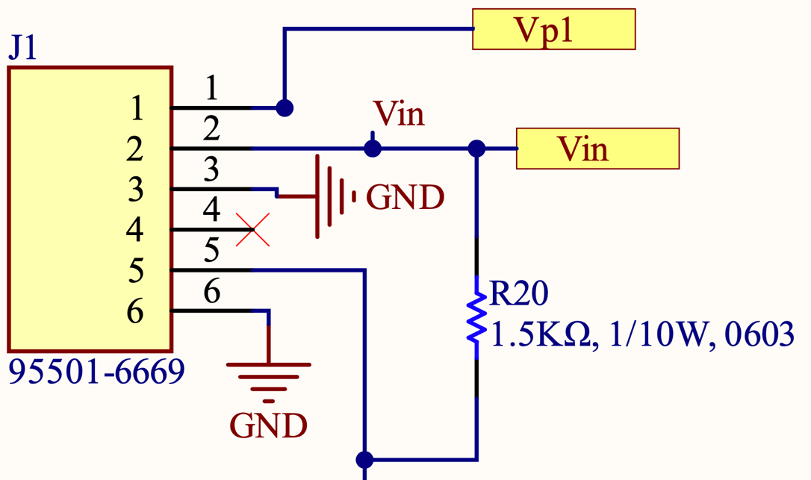

Figure 14

### 3.2.2 Power supply switch

The micro-USB port has multiple shield pins, it is recommended to connect them to ground. In this design this is not necessary as no data will be pulled through the micro-USB port. It is still useful to connect these pins to ground as this strengthens the connection on the PCB. Only the GND and VBUS pin of this port will be used.

Because it has been chosen to be able to supply the product via the P1 port as well as via an external power supply, a circuit is required that switches between these two sources. The intent is that when the external power supply is plugged into the product, power will be drawn from this source and not from the P1 port, regardless of whether the P1 port can provide the power. It should also not be possible for current to flow into one of the power supplies, as this can damage the power supplies.

An option would be to connect both power supplies with two diodes, so that no current can flow into the power supplies. The only drawback is that this system uses all the power from the power supply with the highest voltage. This is of course not the intention, when a customer inserts an external power supply into the device, this power supply must be used.

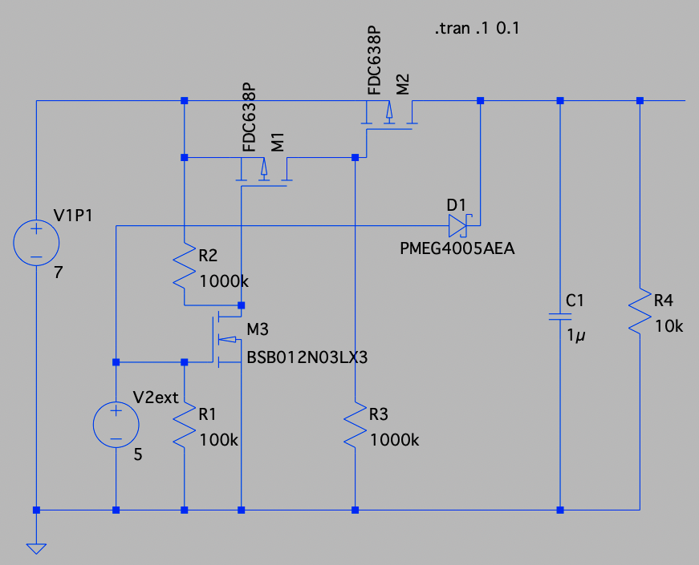

Figure 15

A second option is the circuit shown in Figure 15. When the external power supply is not connected, N-mosfet M3 is pulled low. This mosfet ensures that P-mosfet M1 is pulled high so that it does not conduct. Then P-mosfet M2 is pulled low so that it does conduct and allows the current from the P1 port to pass. When the external power supply is connected, M3 is pulled high so that it goes into conduction, then M1 pulls low and it also goes into conduction, so that M2 is pulled high and does not go into conduction. This means that the external power always has priority. The external power supply only has a voltage drop across diode D1, this is not a problem because the external power supply is at least 5 volts and only 3.3V is used in the rest of the circuit. The PMEG3020EP,115 from Nexperia is used for this diode. This schottky diode was chosen because it has a very low forward voltage of 310mV.

This low forward voltage reduces power losses. In this scheme R4 simulates the load, so this resistor will not be present in the final design. The NX3020NAK,215 is used for the N-channel Mosfet, this is a low power Mosfet. The NX3008PBKW,115,LF is used for the P-channel Mosfet. Two of these Mosfet will be used in the circuit. The N-channel Mosfet has an Rds on of 4.5 Ohms and the P-channel Mosfet has an Rds on of 4.1 Ohms. In both cases this is very little, which means that the waste is minimal with these small currents.

The output of the circuit shown in Figure 15 will then be coupled to pin 2 of the RJ12 port. As a result, there is always a voltage on the request pin higher than the minimum required 4 Volts. As a result, the P1 port will always send data when the product is connected and has a power supply. The output of the circuit shown above will also be connected to the input of the LDO. Figure 16 shows the schematic shown in Figure 15 again with exactly the components to be used.

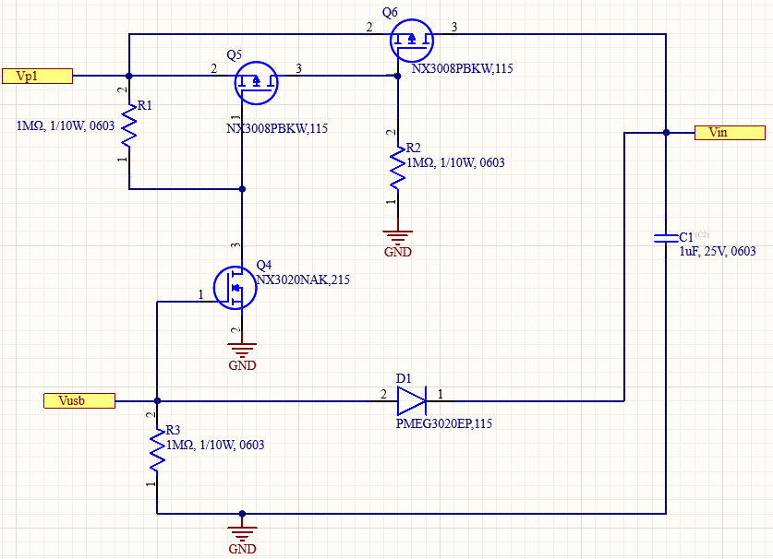

Figure 16

### 3.2.3 Signal converter

The opamp is used as a comparator for the signal converter, Figure 17 shows the circuit used. The positive side of the power supply connects to the 3.3V of the output of the LDO and the negative power side connects to GND. On the positive input of the opamp, the 3.3V is reduced to 1.65V via a voltage divider with two 1MΩ resistors. The signal from the P1 meter is connected to the negative input of the opamp. The voltage divider is necessary to ensure that the opamp does not have to compare two signals that are both at least equal to the supply voltage. This would cause the output of the op amp to become unpredictable.

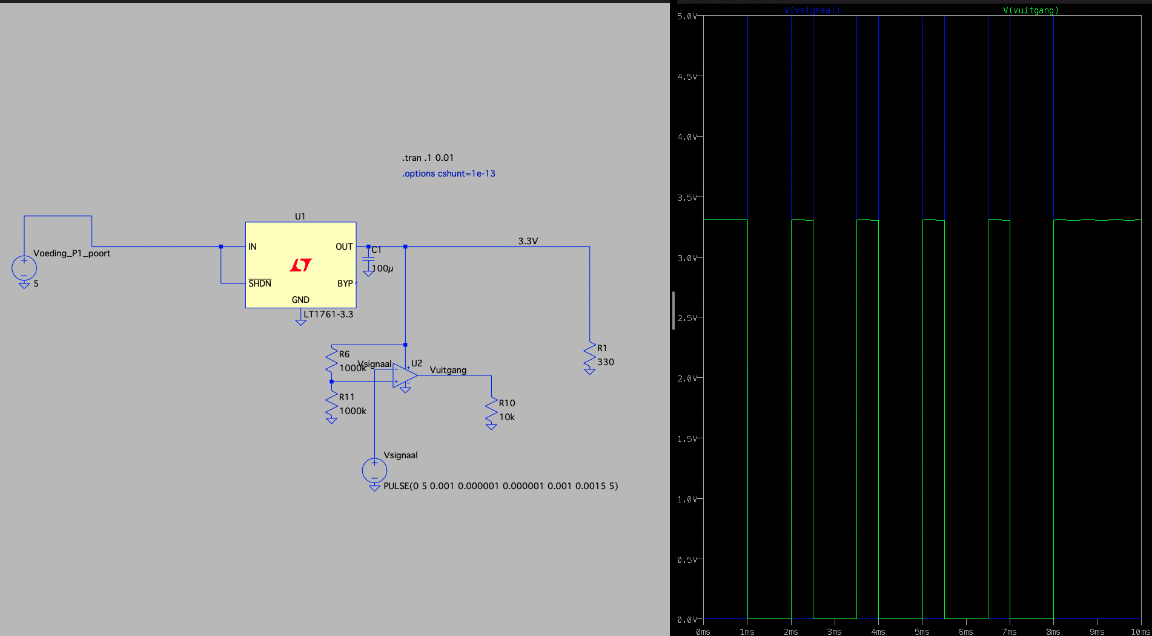

Figure 17

Figure 18 shows the same schematic as in Figure 17 but this time with the correct components.

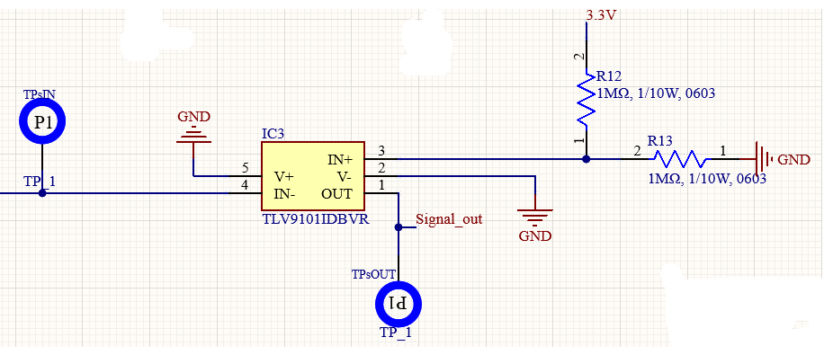

Figure 18

### 3.2.4 Power supply

Figure 19 shows the used schematic. The LDO has a 1µF capacitor on the input and a 2.2F capacitor on the output. These capacitor values are recommended by the datasheet, the average degradation and deviation of the capacitors is also taken into account. This LDO also has a “power good” pin. This pin is not used in this design and the datasheet recommends connecting it to GND for improved heat dissipation. The same applies to the NC pin, this pin has no function at all, but it is also recommended to connect it to GND. The enable pin is coupled directly to the input so that the LDO always works when there is a voltage on the input.

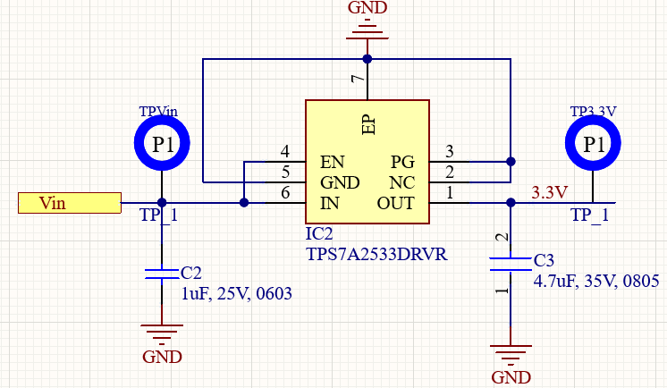

Figure 19

### 3.2.5 MCU

All subsystems will eventually be linked to the ACN52832 module. For debugging, the 2x5 2.54mm smd footprint is used. The pins of this footprint are connected to the NRF52832 in the same way they are now connected in the current Crownstone product. As a result, the code needs to be changed as little as possible for confectioning these pins. This footprint also has the advantage that male headers can be placed on it. This makes programming and debugging a lot easier.

Figure 20 shows the MCU unit and all connections to and from it.

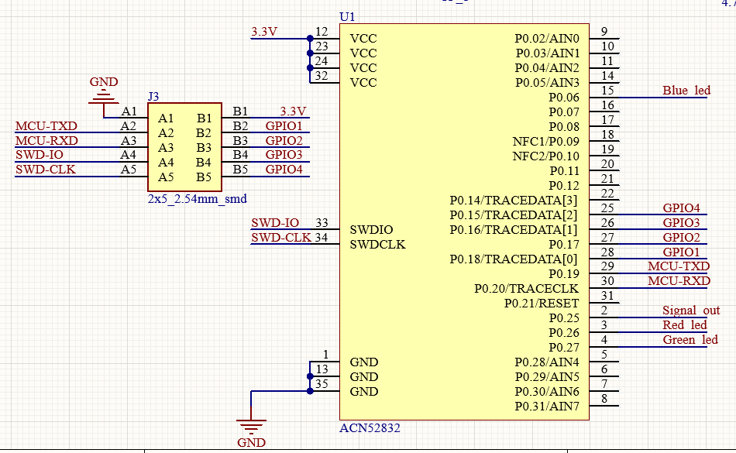

Figure 20

### 3.2.6 LED’s

For switching the chosen RGB LED, it was decided to use the NX3020NAK,215 n-channel Mosfet. This Mosfet has a low input capacitance of 20pF maximum. This Mosfet has already been ordered in a large quantity, which saves the costs of small purchases. A 4.7K ohm resistor is placed between the GPIO pin of the microcontroller and the gate of the Mosfet. This resistance ensures that the instantaneous current is limited and the microcontroller is not damaged during fast switching.

The NRF52832 can dissipate about 25mA of current at a supply voltage of 3.3V and supply even less than that from the GPIO pins (in theory the sink and source current are the same, the NRF only has more GND than Vdd pins so it is not recommended to supply 25mA from the GPIO pins). Figure 21 is taken from the datasheet of the NRF52832. The currents shown are maximum values so it is not recommended to generate a PWM signal that must be able to supply that current. Figure 22 shows 10 cycles of a PWM signal with a 50% duty cycle. With this switching speed, a frequency of $\frac{1}{0.2 × {10}^{-3}} × 10 =50Khz$ is easily achieved, which is more than sufficient.

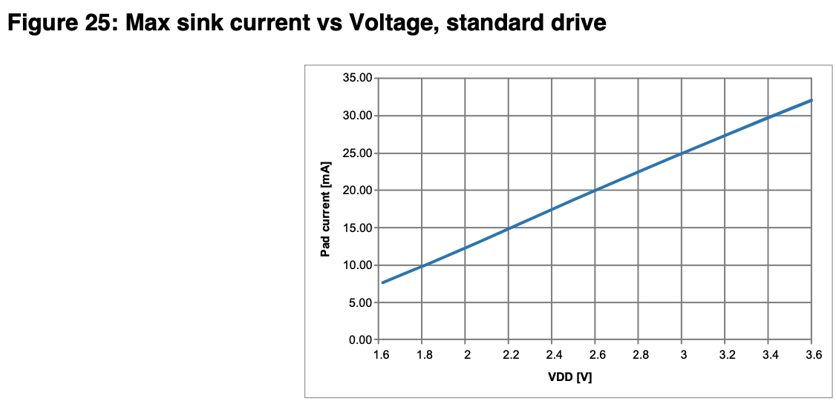

Figure 21

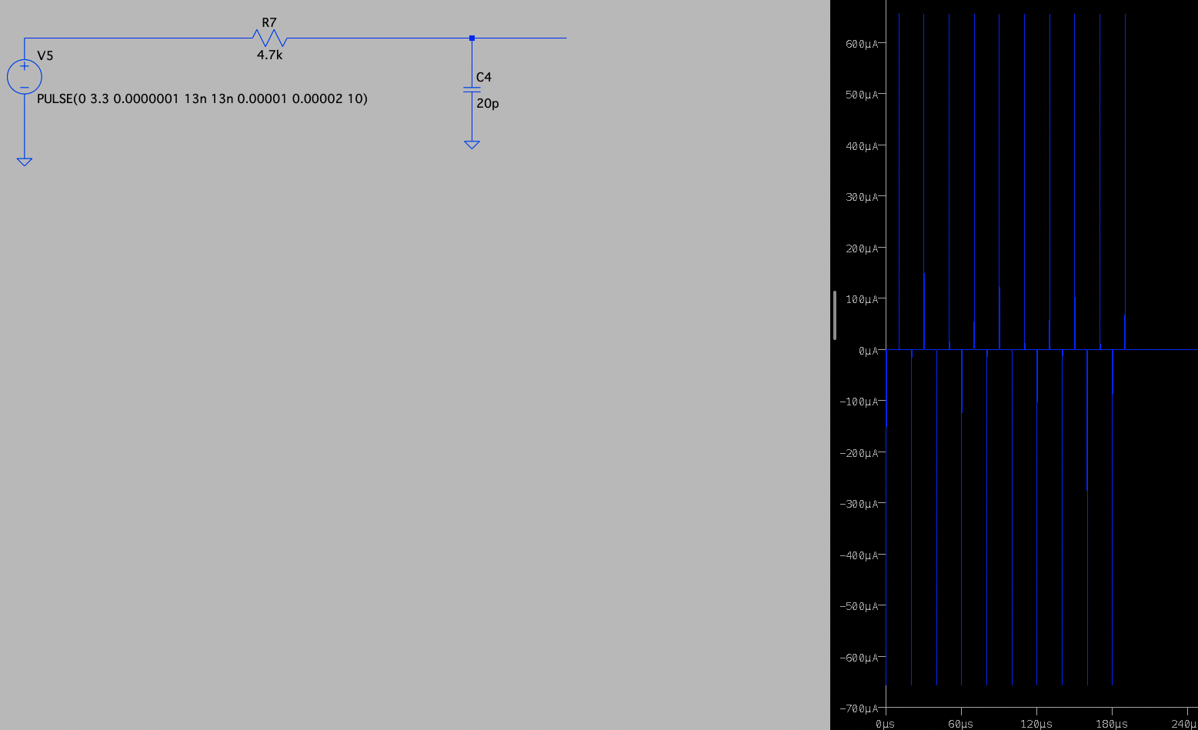

Figure 22

In series with the opamp and LEDs, a resistor is also needed to limit the current. This resistance can be calculated with the following formula:

$$Rs = \frac{Vs-Vf}{If}$$

Here, Rs is the required resistance value, Vs is the supply voltage, Vf is the voltage drop across the LED and If is the maximum current through the LED.

The chosen RGB LED has a different voltage drop across the different LED colors, the maximum current through the red LED is 50mA and through the green and blue LED is 35mA. The red LED has a nominal voltage drop of 2.1V, the green LED of 2.8V and the blue LED of 3.0V. The RDSon of the Mosfet is between 3Ω and 13Ω. This resistor is also in series with the LED. When choosing the resistance value, it is useful to assume a low RDSon so that only less current can flow and no more. It has been decided to limit the current to 15mA max, so the LED will not break quickly. A resistance of the following is required for the red LED:

$$Rsr= \frac{3.3-2.1}{15 × {10}^{-3}}=80Ω$$

For the green LED a resistance of:

$$Rsg= \frac{3.3-2.8}{15 × {10}^{-3}}=33.3Ω$$

For the blue LED a resistance of:

$$Rsb= \frac{3.3-3.0}{15 × {10}^{-3}}=20Ω$$

From this value the minimum RDSon of the Mosfet is subtracted, Rsr = 80 – 3 = 77Ω,

Rsg = 33.3 – 3 = 30.3Ω and Rsb = 20 – 3 = 17Ω. The available resistances that come close to this are: Rsr = 82Ω, Rsg = 33Ω and Rsb = 18Ω.

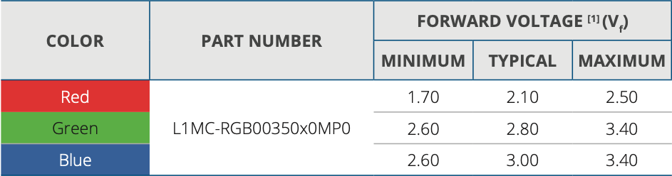

Figure 23

The calculations shown above are based on the nominal voltage drop. Figure 23 also shows the minimum and maximum voltage drop. When the LED has a higher voltage drop than the nominal value, the LED will glow less brightly and use less current. Conversely, if the LED has a lower voltage drop than its rated value, the LED will glow brighter and use more current. Burning less bright is not such a problem, burning brighter can be a problem.

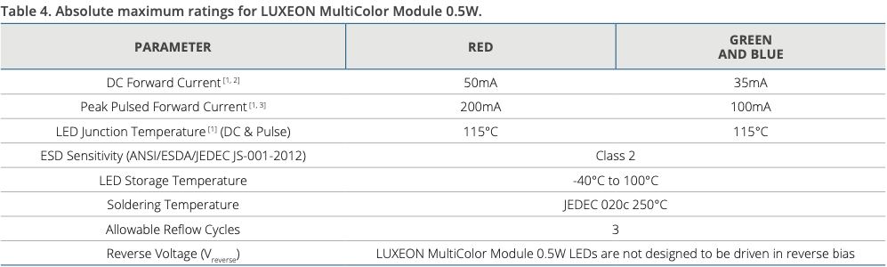

Figure 24

Figure 23 and Figure 24 are taken from the datasheet of the LED [12]. Figure 24 shows the maximum allowable current at the top of the table, as long as the current remains below these values the LEDs will continue to function properly for a long time. Taking into account the minimum voltage drops for the LEDs and an even lower RDSon of the mosfet of 2Ω, the following maximum currents can be calculated.

For the red LED:

$$Irmax= \frac{3.3-1.7}{2+82}≈19mA$$

For the green LED:

$$Igmax= \frac{3.3-2.6}{2+33}=20mA$$

For the blue LED:

$$Ibmax= \frac{3.3-2.6}{2+18}=35mA$$

In the case of the blue LED, the maximum allowable current of 35mA can be achieved, so this is fine. The chance that this current is achieved is very small, the LED must have a very low voltage drop, the mosfet a low RDSon and in addition all lines on the PCB must also have an infinitely low resistance if this current is to be achieved. In addition, in practice the LED will often still be dimmed by means of pulse width modulation.

In this design, the NX3020NAK,215 n-channel Mosfet is used for switching the individual LEDs.

Figure 25 shows the above explained circuit with the connections to the MCU unit.

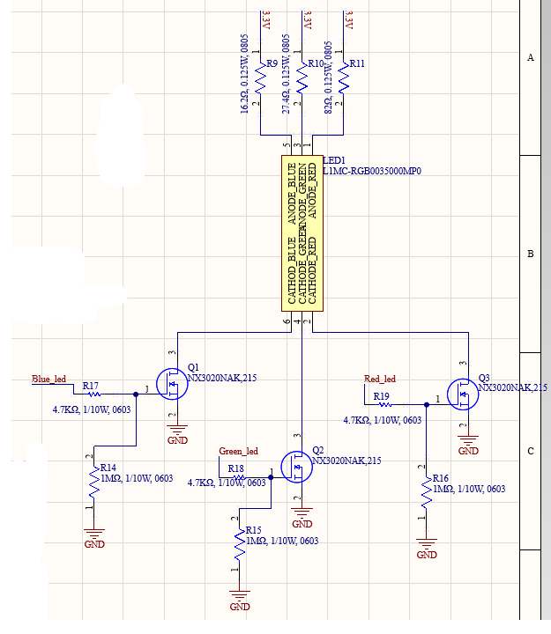

Figure 25

### 3.2.7 Other

In addition to all individual units, other parts have also been designed. Another component is the test points. Test points are very important because they allow easy measurement of different voltages in the PCB while the PCB is already fully fabricated. The blue circles containing P1 seen in previous figures represent the test points used. It has been chosen to set a test point on the input voltage, the input signal of the signal converter, the output signal of the signal converter, the output of the LDO and GND.

# 4. Unit tests

In this chapter the different unit tests will be described and when performed the test results will be placed directly below them.

## 4.1 RJ12 connector

This test is easy to perform, but it is important. When a connection is broken internally, it would take a very long time before the discovery is made that the connector is broken when it is already soldered on the PCB.

### 4.1.1 RJ12 connector test

|  |  |
| --- | --- |
| Necessities | * Multimeter |
| Steps | * Step 1: Set the multimeter to the continuity test function. * Step 2: Measure that each of the pins on the bottom of the connector are connected to the pins on the inside of the connector. |
| Completed | If no problems are found in the last step, the test has been successfully completed. |

Figure 26

### 4.1.2 Test result RJ12 connector

This test passed, each of the pins on the inside is connected to the correct pin on the bottom.

## 4.2 Power supply switch

It is important that the power supply switch is first tested as an individual system. If this were only tested during integration, other systems could be damaged by a non-functioning power supply.

### 4.2.1 Power supply switch test

|  |  |
| --- | --- |
| Necessities | * Dual lab bench power supply * Oscilloscope * Multimeter |
| Steps | * Step 1: Set both sides of the lab bench power supply to 5V with a current limit of 250mA * Step 2: Set the multimeter to measure current * Step 3: Put the multimeter in series with the output of the left side of the power supply * Step 4: Connect the left side of the power supply with the multimeter in series to the P1 input of the circuit * Step 5: Connect the right side of the power supply to the micro-USB side of the circuit. * Step 6: Connect the oscilloscope to the output of the circuit * Step 7: Connect a 56Ω resistor to the output, this resistor simulates the load of the rest of the circuit * Step 8: Turn on the left side of the power supply and check on the oscilloscope if the voltage is at least 4.5V * Step 9: Turn on the right side of the power supply and check on the oscilloscope if the voltage is at least 4.1V * Step 10: Check on the multimeter whether the current from the left power supply reaches a maximum of 0.1mA. |
| Completed | If the voltage drops below 4V for a maximum of 500ms and the current from the left side of the power supply is less than 0.1mA when the right power supply is on, the test is successful. |

Figure 27

### 4.2.2 Test result power supply switch

When both power supplies were turned on, the following image was displayed: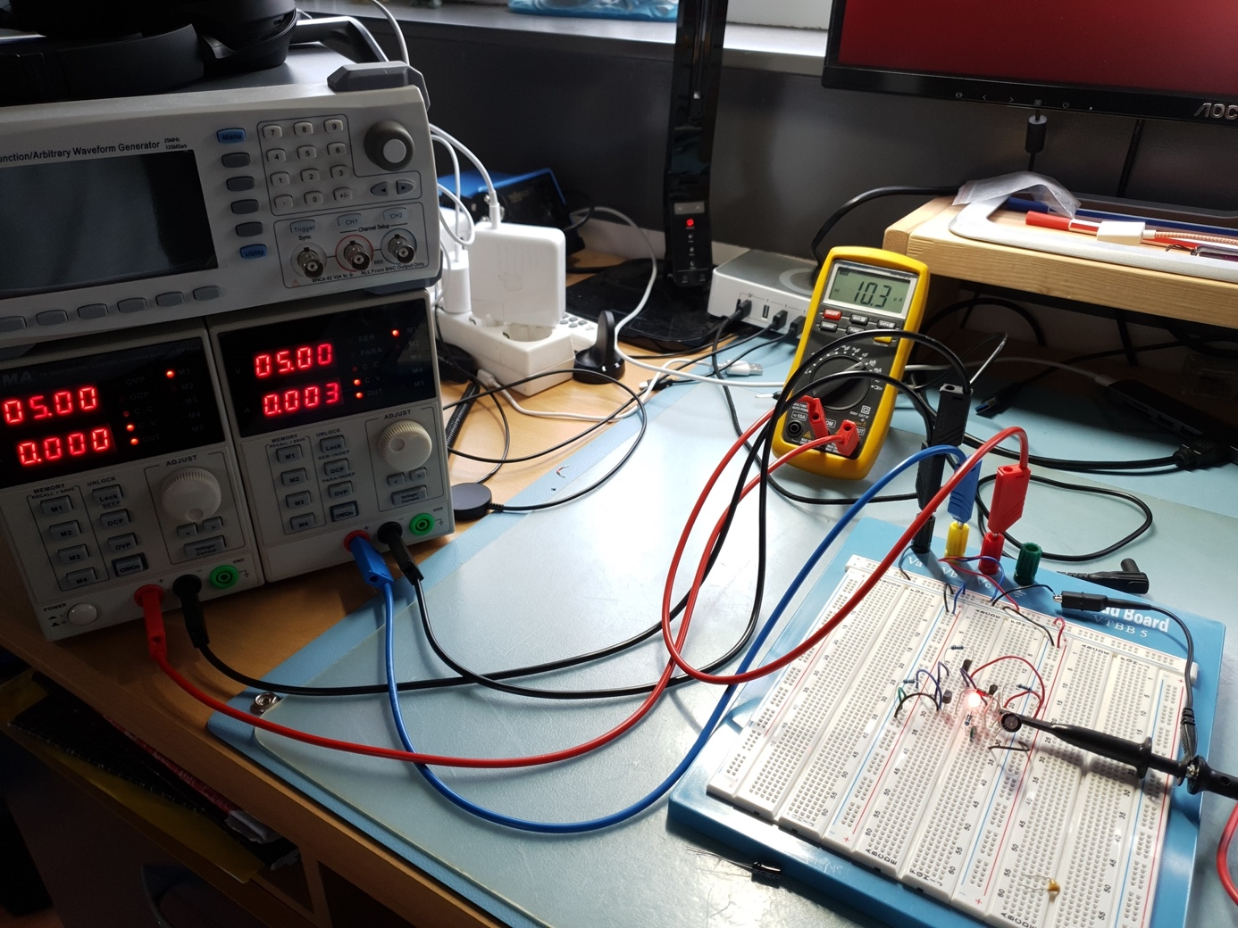

Figure 28

Figure 28 show the test setup. The left side of the lab power supply simulates the P1 power source and the right side of the lab power supply simulates the micro USB power source. The multimeter indicates a current of 10.3uA. This is less than 0.1mA so this part of the test passed. The following images were shown on the oscilloscope connected to the output of the circuit:

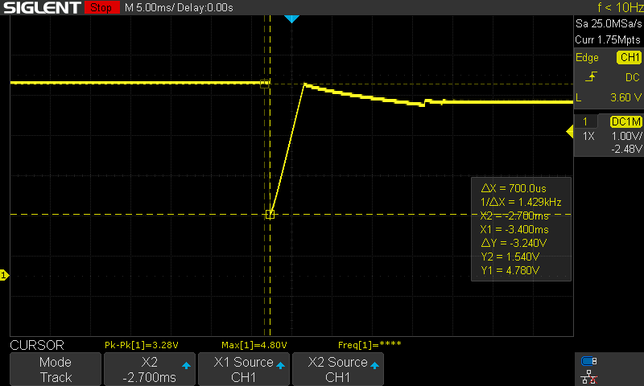

Figure 29

Figure 29 shows the behavior after turning on the micro-USB side of the lab bench power supply. By switching the Mosfets, a dip can be seen in the output voltage. To the left of the dip is the voltage from the left side of the lab power supply and to the right of the dip is the voltage from the right side of the lab power supply. Although both the left and right sides of the lab power supply have the same settings, the power supplies give a different output voltage after switching. As long as these voltages remain above 3.4V, the entire circuit works fine. If the voltage would drop that far, relatively large losses would occur, hence the requirement that the left side must remain above 4.5V and the right side above 4.1V. Y1 shows the voltage on the left, which is 4.78V.

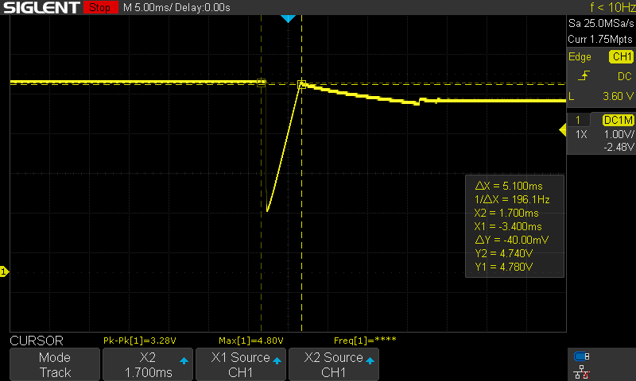

Figure 30

Figure 30 shows that Y2 = 4.74V. Just after cursor Y2 the voltage drops slightly again to 4.5V. This is higher than 4.1V so this part of the test also passed. Figure 30 also shows the duration of the dip by means of ΔX, which is 5.1ms. This is well within the set requirement of 500ms, so this last part of the test also passed.

## 4.3 Signal converter

The signal converter needs a minimum slew rate of $2.61V/{us}$ as described in section 1.4 in order to properly convert the signal from the P1 port.

### 4.3.1 Signal converter test

|  |  |
| --- | --- |
| Necessities | * Signal generator * Oscilloscope * Lab bench power supply |
| Steps | * Step 1: Set the lab bench power supply to 3.3V with a current limit of 10mA. * Step 2: Set the function generator to a PWM signal with a duty cycle of 80% and a peak voltage of 5V * Step 3: Set the function generator to HighZ. * Step 4: Connect the lab bench power supply to the power pins on the unit. * Step 5: Connect the function generator to the signal input and GND of the unit. * Step 6: Connect the oscilloscope to the signal output and GND of the unit. * Step 6: Turn on the lab bench power supply and check the oscilloscope to see if the unit's output is at 0V. * Step 7: Turn on the function generator at a frequency of 100kHz * Step 8: Turn on the oscilloscope * Step 9: Vary the frequency of the function generator until the signal on the oscilloscope just has flat tops * Step 10: Measure the duration of the rise time with the cursors |
| Completed | The test is considered successful when the oscilloscope shows that the duration of the rise time is a maximum of 1.26µs with a maximum deviation of 5% |

Figure 31

### 4.2.2 Test result signal converter

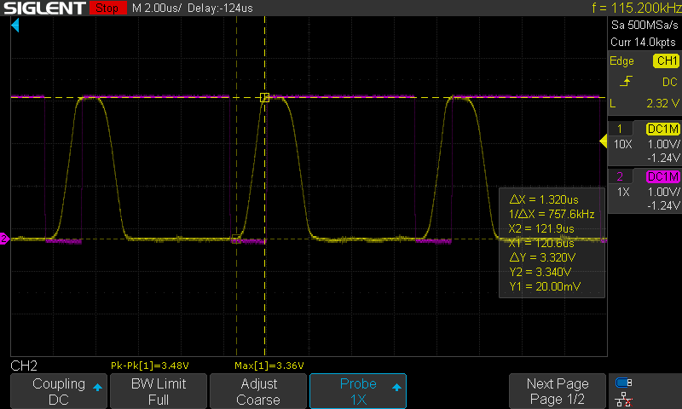

Figure 32

Figure 32 shows the minimum acceptable pulse duration. Here it can be seen that the rise time is ∆X 1.32us. This is still within the required margin but is not perfect. These imperfections are caused by the measurement setup. The voltage difference ∆Y is 3.32V, this gives a slew rate of $\frac{3.32V}{1.32us}=2.5V/{µs}$. This opamp should have a slew rate of $4.5V/{µs}$. This is a very big difference which is caused by the long wires of the test rig. This measured slew rate is sufficient but will be better when the opamp is soldered to a PCB.

## 4.4 Voltage converter

It is very important to test the voltage converter separately from the rest of the system. If there is a fault in this unit, it could easily damage the microcontroller.

### 4.4.1 Voltage converter test

|  |  |
| --- | --- |
| Necessities | * Lab bench power supply * Oscilloscope |
| Steps | * Step 1: Connect the oscilloscope to the output of the LDO. * Step 2: Set the lab bench power supply to 5V with a current limit of 100mA. * Step 3: Put a 56Ω resistor on the output of the LDO * Step 4: Turn on the lab bench power supply. * Step 5: Check the oscilloscope to see if the LDO outputs a continuous voltage of 3.3V. |
| Completed | The test may be considered successful if the oscilloscope shows a continuous voltage of 3.3V with a maximum deviation of 5 percent. |

Figure 33

### 4.4.2 Test result voltage converter

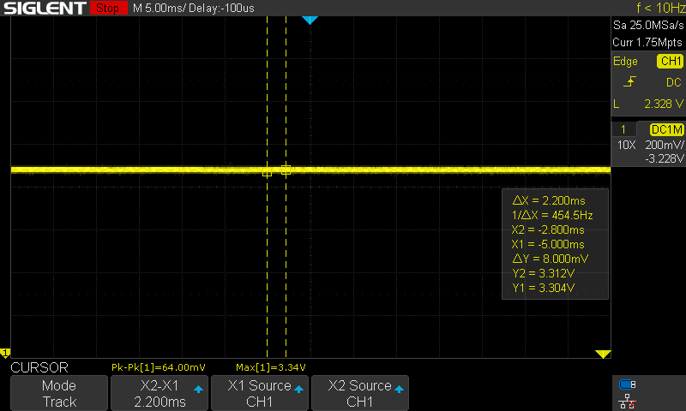

Figure 34

Figure 34 shows the oscilloscope image of the output of the test rig. Here it can be seen that a maximum voltage of 3.34V is measured, that the cursor Y1 measures 3.304V and the cursor Y2 measures 3.312V. All these values are well within the maximum allowable voltage of 3.465V so this test is considered successful.

# 5. Integration test

In the integration test, different units are merged. This involves testing whether the individual units also work together as they should. This integration test is performed on a designed PCB and not on a breadboard. A breadboard gives too much uncertainty in the measured results.

## 5.1 Units power supply switch and unit voltage converter

In this test, the power supply and voltage converter units will be combined.

### 5.1.1 Test units power supply switch and voltage converter

|  |  |
| --- | --- |
| Necessities | * Dual lab bench power supply * Oscilloscope |
| Steps | * Stap 1: Soldeer alle componenten op de PCB. * Stap 2: Stel beide kanten van de labvoeding in op een spanning van 5V met een stroombegrenzing van 20mA. * De linker kant van de labvoeding stelt de voeding vanuit de P1 poort voor, sluit deze kant van de voeding aan op de voedingsdraden van de RJ12 kabel. * De rechter kant van de labvoeding stelt de voeding vanuit de micro-USB poort voor, sluit deze kant van de voeding aan op de voedingsdraden van de micro-USB kabel. * Steek beide kabels in de desbetreffende poorten op de te testen PCB. |
| Completed |  |

Figure 35

### 5.1.2 Test result units power supply switch and voltage converter

…….

## 5.2 Units LED’s, power supply switch and voltage converter

### 5.2.1 Test units LED’s, power supply switch and voltage converter

|  |  |
| --- | --- |
| Necessities | * Function generator * Custom P1 port test connection * Multimeter * Dual lab bench power supply * Oscilloscope |
| Steps | * Step 1: Set the left side of the power supply to a voltage of 5V with a current limitation of 100mA. * Step 2: Set the function generator to a square wave with a Vpp of 3.3V, an offset of 1.65V, a frequency of 100Hz and a duty cycle of 1%. * Step 3: Set the multimeter to the mA setting and place it between the positive output of the lab power supply and the blue wire (V+) of the P1 port test connection. * Step 4: Connect the negative output of the lab power supply to the white wire (V-). * Step 5: Plug the RJ12 plug of the P1 test socket into the RJ12 port on the PCB to be tested. * Step 6: Connect the negative lead from the function generator to the green wire of the P1 test terminal. * Step 7: Connect the positive lead of the function generator to a loose wire. * Step 8: Turn on the lab power supply. * Step 9: Turn on the function generator. * Step 10: Place the connected loose wire on pin 3 of the ACN52832 footprint. This pin controls the red LED. * Step 11: See if the red LED lights up. * Step 12: Check the multimeter to make sure that the voltage does not exceed 20 mA. * Step 13: Now set the duty cycle to 100%. * Step 14: See if the multimeter reads 15mA. * Step 15: Is the multimeter not showing 15mA? Then measure the voltage drop across the LED. If the voltage drop is higher than the nominal value, the LED may use less current. If the voltage drop is lower than the nominal value, the LED may use more current up to a maximum of 35mA. * Step 16: Repeat steps 10 to 15 for pins 4(green) and 15(blue). |
| Completed | The test is passed when the current consumption is approximately 15mA or when a lower or higher current consumption up to a maximum of 35mA can be justified by a lower or higher voltage drop than the nominal value. |

Figure 36

### 5.2.2 Test result units LED’s, power supply switch and voltage converter

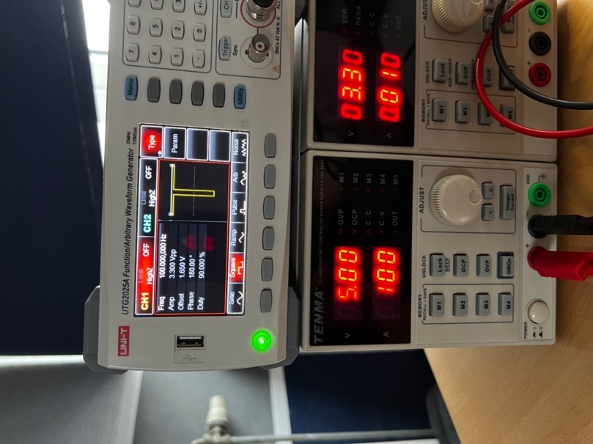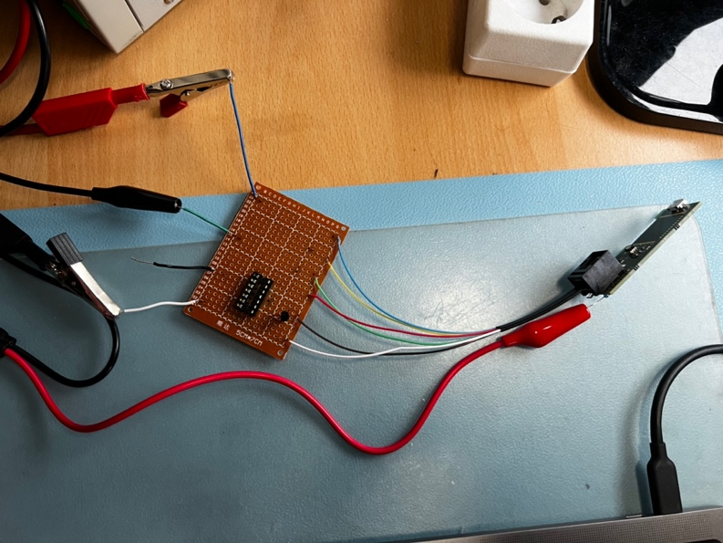

Figure 37

Figure 37 shows the settings of the function generator and lab bench power supply and the test setup with the P1 test board on the left and the test PCB on the right.

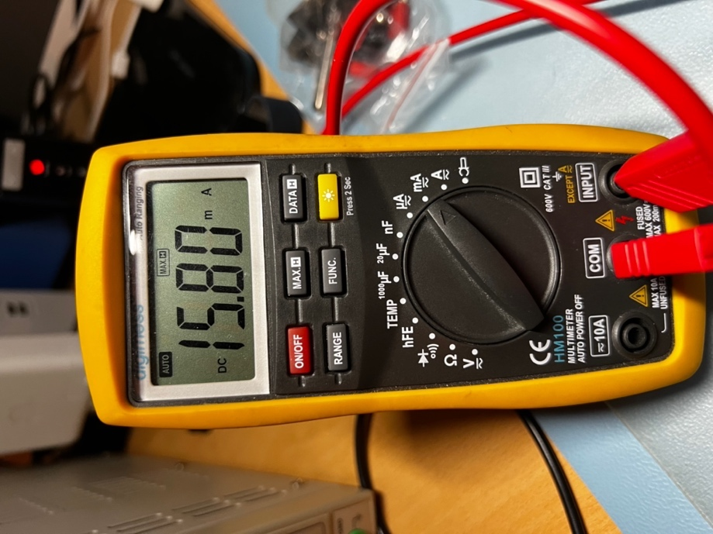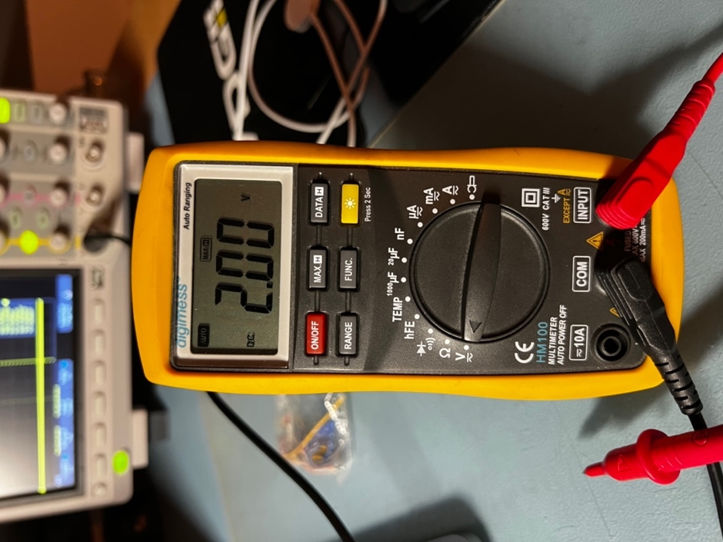

Figure 38

Figure 38 shows the measured current through the red LED and the voltage drop across the red LED. The current is slightly higher than 15mA but the voltage drop is slightly lower than the nominal voltage drop so this test passed.

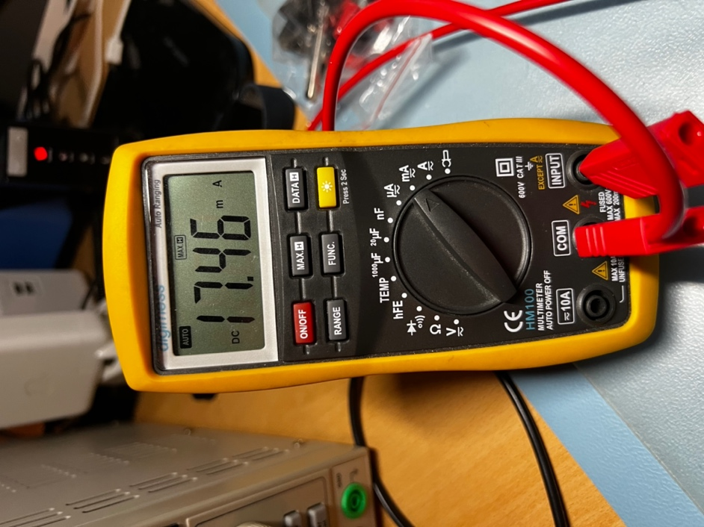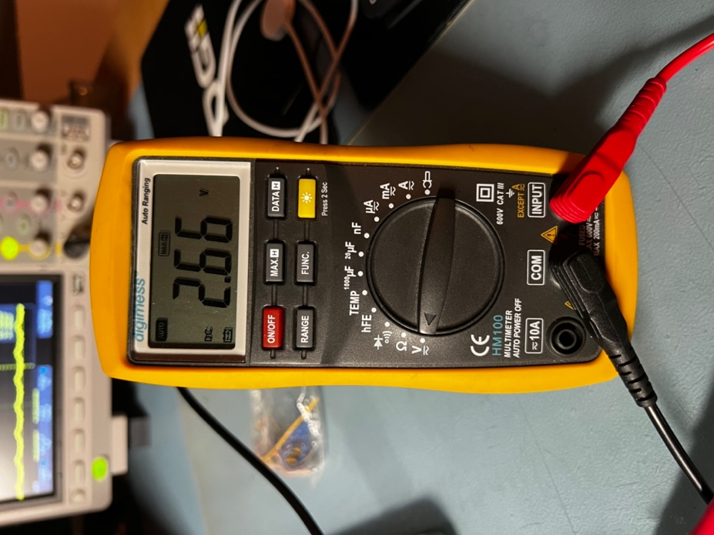

Figure 39

Figure 39 shows the current through the green LED and the voltage drop across the green LED. Again, the current is slightly higher than 15mA and the voltage drop is lower than the nominal 2.8V. The higher current can therefore be explained, so this test was passed.

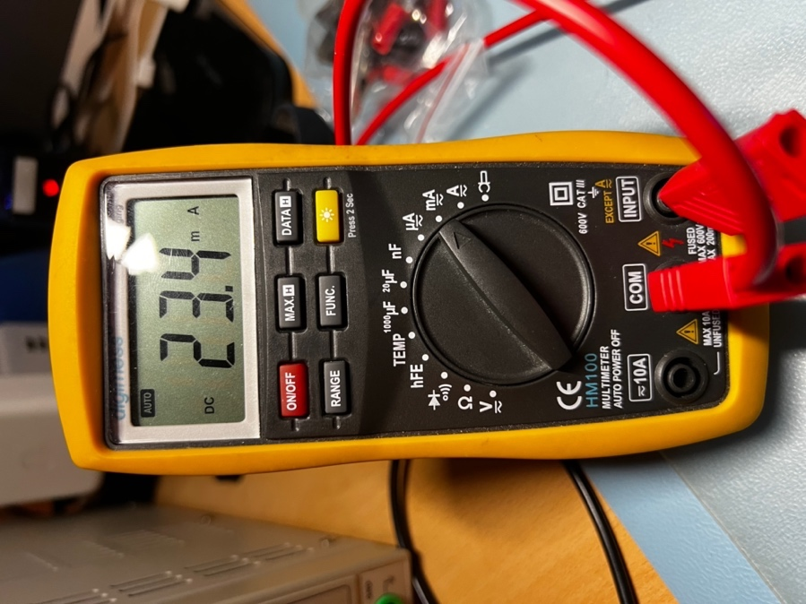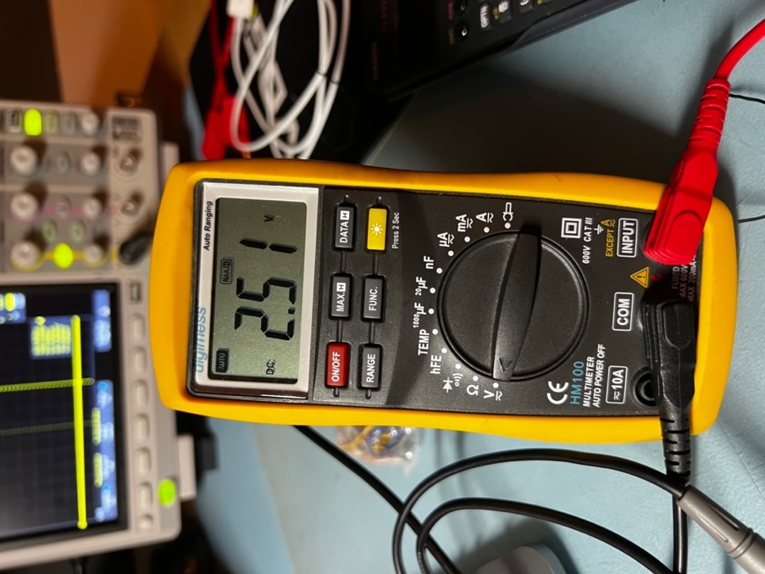

Figuur 40

Figuur 40 shows the current through the blue LED and the voltage drop across the blue LED. This current is quite a bit higher than the expected 15mA. When looking at the voltage drop across the blue LED, this current can be explained. This voltage drop is even lower than the specified minimum voltage drop. As expected, even in this case the 35mA is not reached due to the imperfect components, so this test was also successful.

# 6. PCB-design

To design the PCB, the first thing that’s needed is a complete schematic.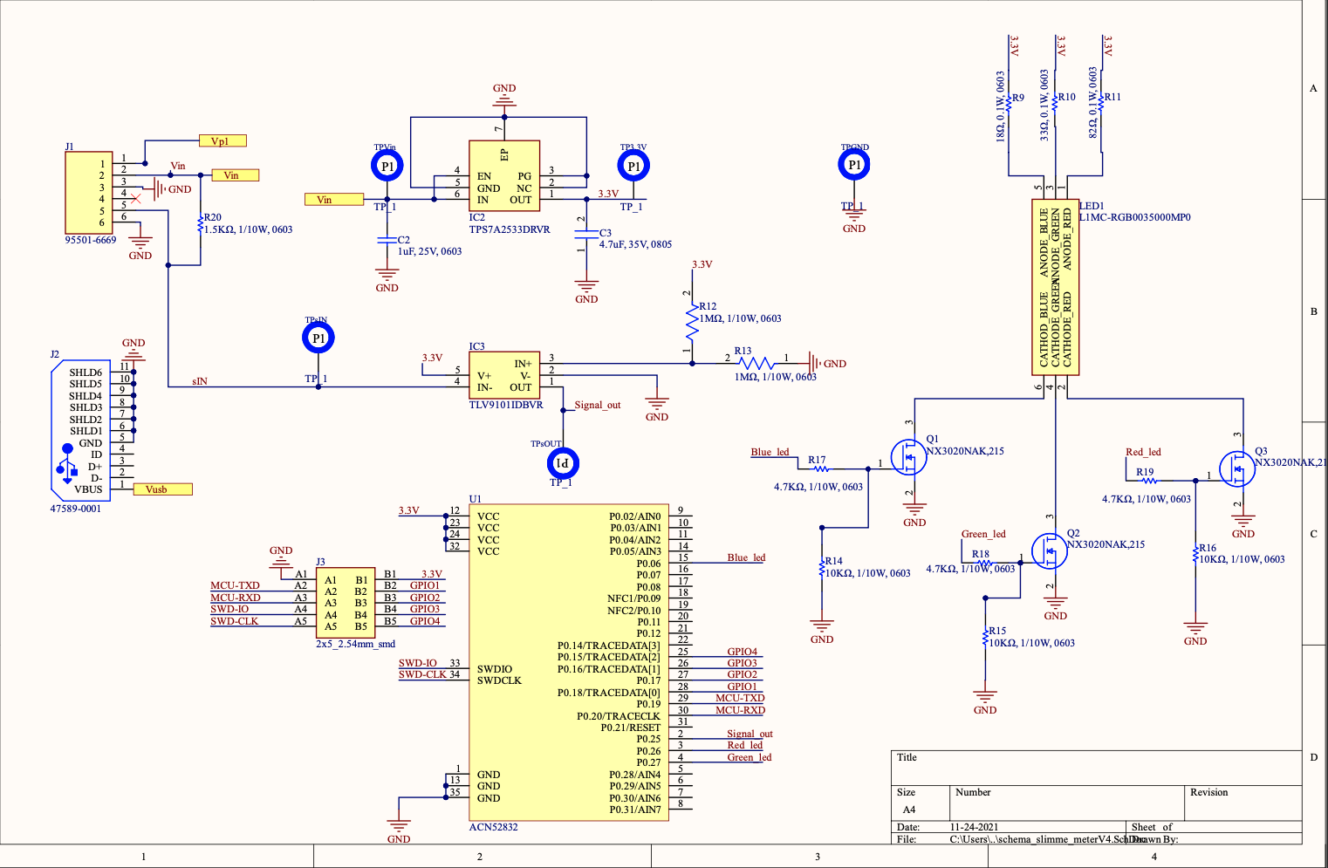

Figure 41

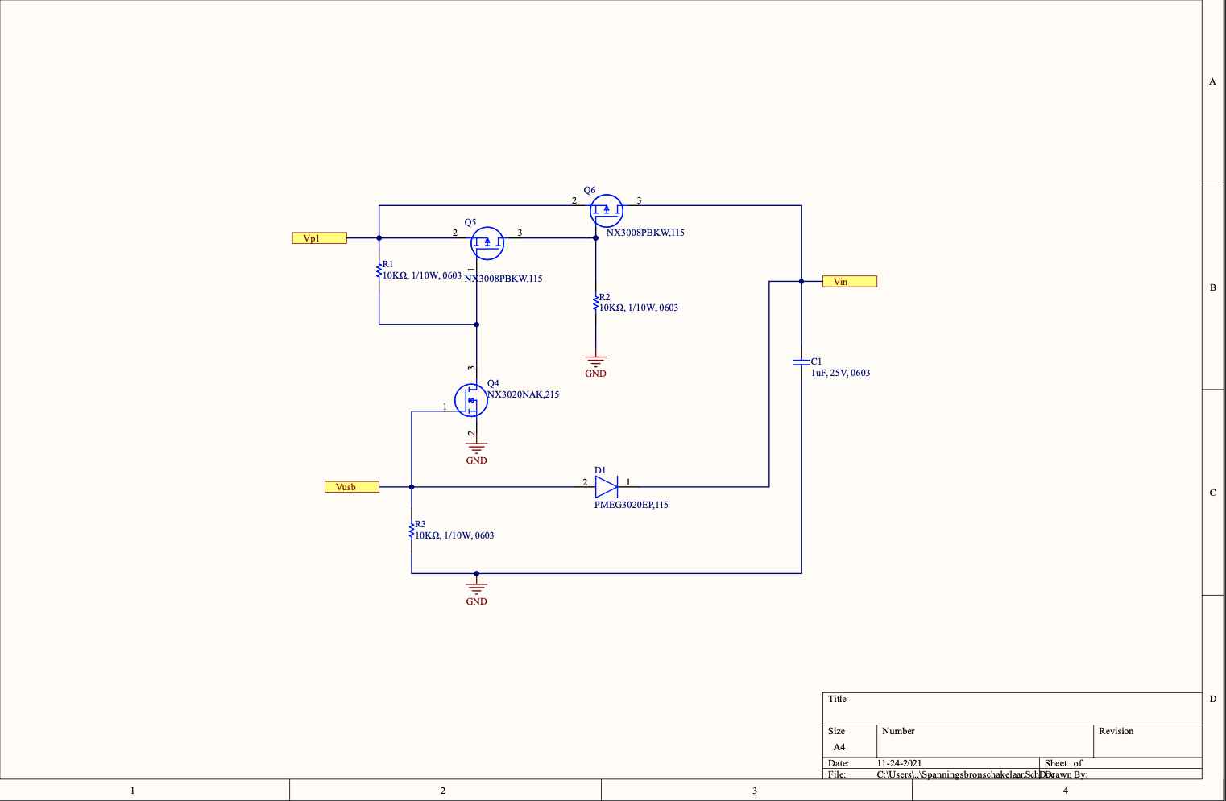

Figure 42

Figure 41 and Figure 42 show the final schematic. This diagram was then imported into Altium's PCB editor, after which the layout of the PCB could be started. To minimize the size of the PCB, it was decided to place components on both sides. This makes assembly a bit more difficult but saves a lot of space compared to placing all components on one side.

A requirement for the PCB design was that the design should be made as small as possible without limiting functionality. As small as possible and without limiting functionality is not very concrete, but finding a balance is important here. For example, using a module for the NRF52832 is not very efficient when it comes to minimizing the design, but it has enough advantages to overshadow the advantages of a standalone NRF. The final PCB can be seen in Figure 43and is 2.54cm wide and 5.92cm high.

This design achieves a good balance between dimensions and functionality. For example, for the Bluetooth range it would have been even better to have the antenna side of the module fully protrude. It has now been decided to make a cut-out in the PCB and not to run power planes directly next to it. As a result, the Bluetooth performance is most likely very close to a module with a fully protruded antenna without taking up so much space.

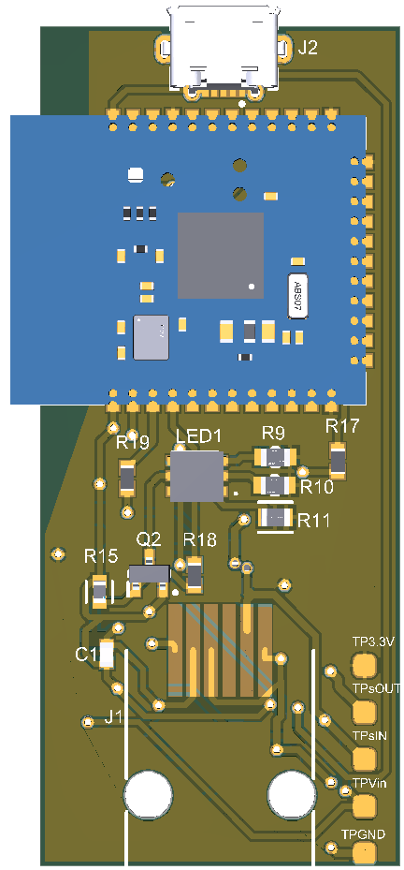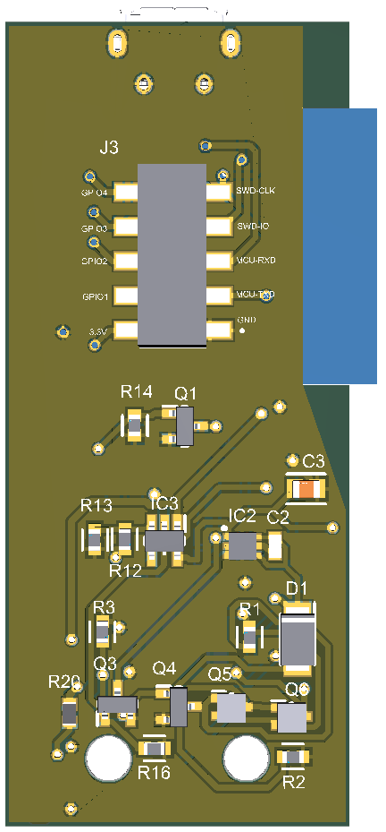

Figure 43

Furthermore, it has been decided to place the test points at the bottom right, this makes it possible to clamp the GND of a probe to the GND point and use the tip of the probe to go over the other test points. The RJ12 connector will be placed next to the test points and in the two large holes at the bottom. The micro-USB port can be seen at the very top. By placing them opposite each other, the PCB can hang from the RJ12 connector in the P1 port and be supplied with power via the micro-USB port if necessary. Because these two connectors are placed opposite of each other, the stresses on the connectors and cables remain minimal when they are connected. In addition, as there can be seen in Figure 43, it was decided to place components on both sides of the PCB. This makes assembly more complicated, but it saves a lot of space. The J3 connector can also be seen at the bottom. This is the 2x5 2.54mm smd footprint for debugging the microcontroller and potentially adding features through four available GPIO pins.

A minimum of 0.5mm diameter vias are used in this design and the copper layers are 0.3mm from the edge. Because of this, many PCB manufacturers accept this PCB without it becoming very expensive.

# 7. Acceptance test

The acceptance test is all about testing the fully assembled final product against the customer's requirements. In every test, at least the fully assembled board with the final software on it is used. For convenience, “the fully assembled board with the final software” will hereinafter be referred to as the “final product”.

## 7.1 Test 1:

### 7.1.1 Execution test 1:

|  |  |
| --- | --- |
| Requirement(s) | * REQ-1: The product must be able to be connected to the P1 port of a smart meter. |
| Necessities | * Custom P1 port test connection * Multimeter |
| Test Input | The RJ12 plug of the test connection will be plugged into the final product and the probes of the multimeter will be used as continuity probes. |
| Test Output | As a test output, an audible click is expected when the RJ12 plug is inserted into the final product. In addition, multiple beeps from the multimeter are expected during the course of the test. |
| Steps | 1. Insert the RJ12 plug of the self-designed P1 port test connection into the finished product, can you hear a clear click? 2. Set the multimeter to continuity test mode. 3. Make sure that the flattest side of the finished product is facing down and that the soldered side of the custom P1 port test connection is facing up, this causes the cable to be twisted. 4. Place the red probe on the blue wire of the test connection and the black probe on the top soldering point of the RJ12 port on the finished product. Can you hear a beep from the multimeter? 5. For the remaining five checks, the red probe must be moved up one wire at a time and the black probe down one solder point at a time. Is a beep audible from the multimeter each of these times? |
| Completed | The test is complete when a beep from the multimeter was heard at both the first test point and all subsequent test points, and when a distinct click was heard at step one. This means that a good connection to the P1 port of a smart meter is possible. |

Figure 44

### 7.1.2 Result test 1

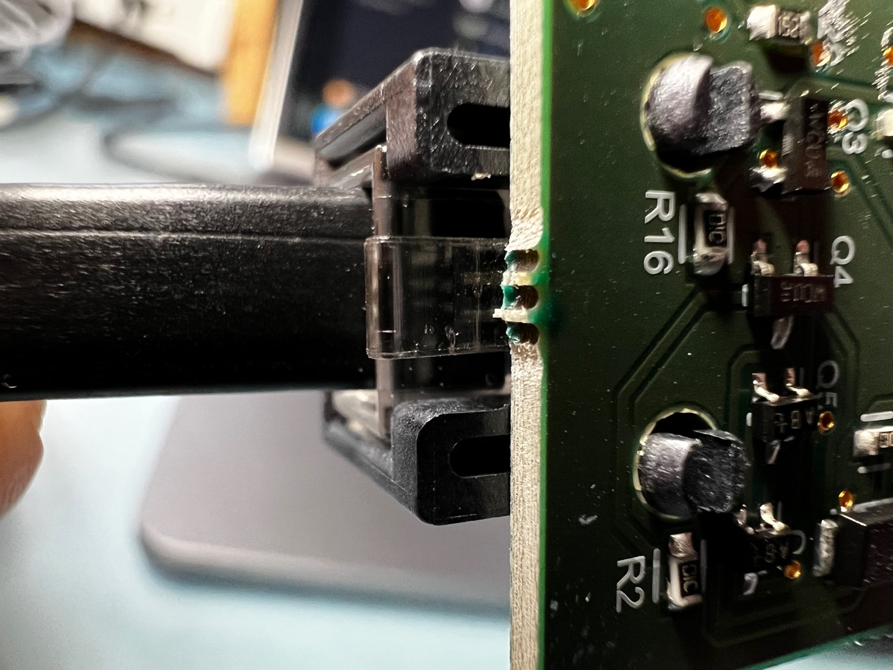

Figure 45

Figure 45 shows that the connector is flush with the port, this is exactly as it should be. When connecting, a clear click could also be heard.

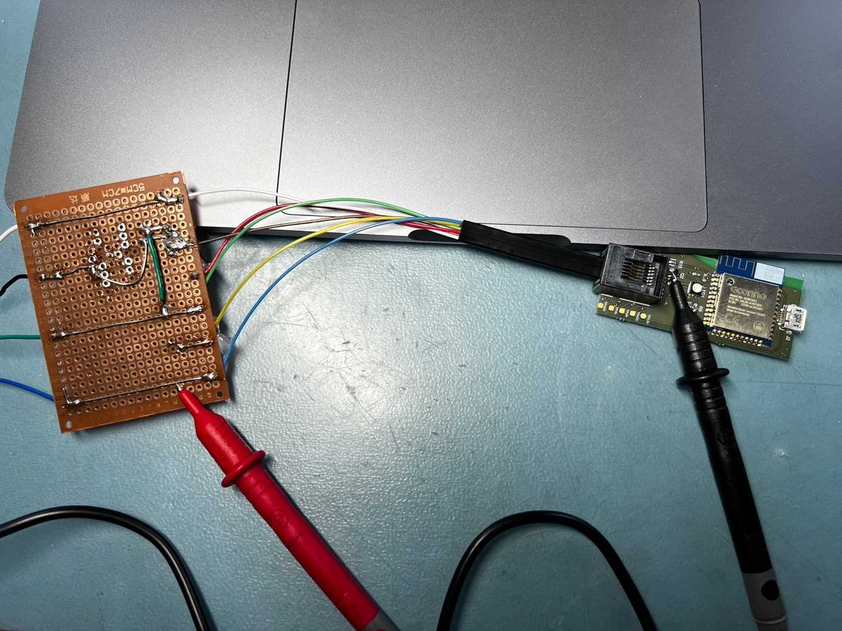

Figure 46

Figure 46 shows the complete test setup. This test was performed according to the steps mentioned in Figure 44. At each of the measurement moments, a clear beep was heard from the multimeter. This means that a good connection is possible with the P1 port of the smart meter and that this test was successful.

## 7.2 Test 2:

### 7.2.1 Execution test 2:

|  |  |
| --- | --- |
| Requirement(s) | * REQ-2: The product must be able to receive power through the P1 port of a smart meter. |
| Necessities | * Custom P1 port test connection * Lab bench power supply |
| Test Input | A voltage of 5V is required as test input. |
| Test Output | The blue LED is expected to light up. It must also be possible to connect to the final product at this point. |
| Steps | 1. Set the lab bench power supply to an output voltage of 5V with a current limit of 100mA. 2. Plug the RJ12 connector of the test connection into the RJ12 port of the final product. 3. Connect the positive output of the lab bench power supply to the blue wire of the test connection. 4. Connect the negative output of the lab bench power supply to the white wire of the test connection. 5. Connect the black wire from the test connection to the positive output of the lab bench power supply as well. 6. Turn on the lab bench power supply. Does the blue LED light up? |
| Completed | The test is completed when the blue LED lights up. |

Figure 47

### 7.2.2 Result test 2:

When the blue LED lights up, it means that the current is flowing properly and that it is being converted to the correct voltage. The black wire from the test terminal is the signal input. Because a UART signal should normally be high, it should be high in this test. When a high signal or a continuous dc voltage is applied to this wire, a mosfet will become conductive. This mosfet then pulls the voltage down, just like in the smart meter. This is then inverted again by the rest of the circuit.

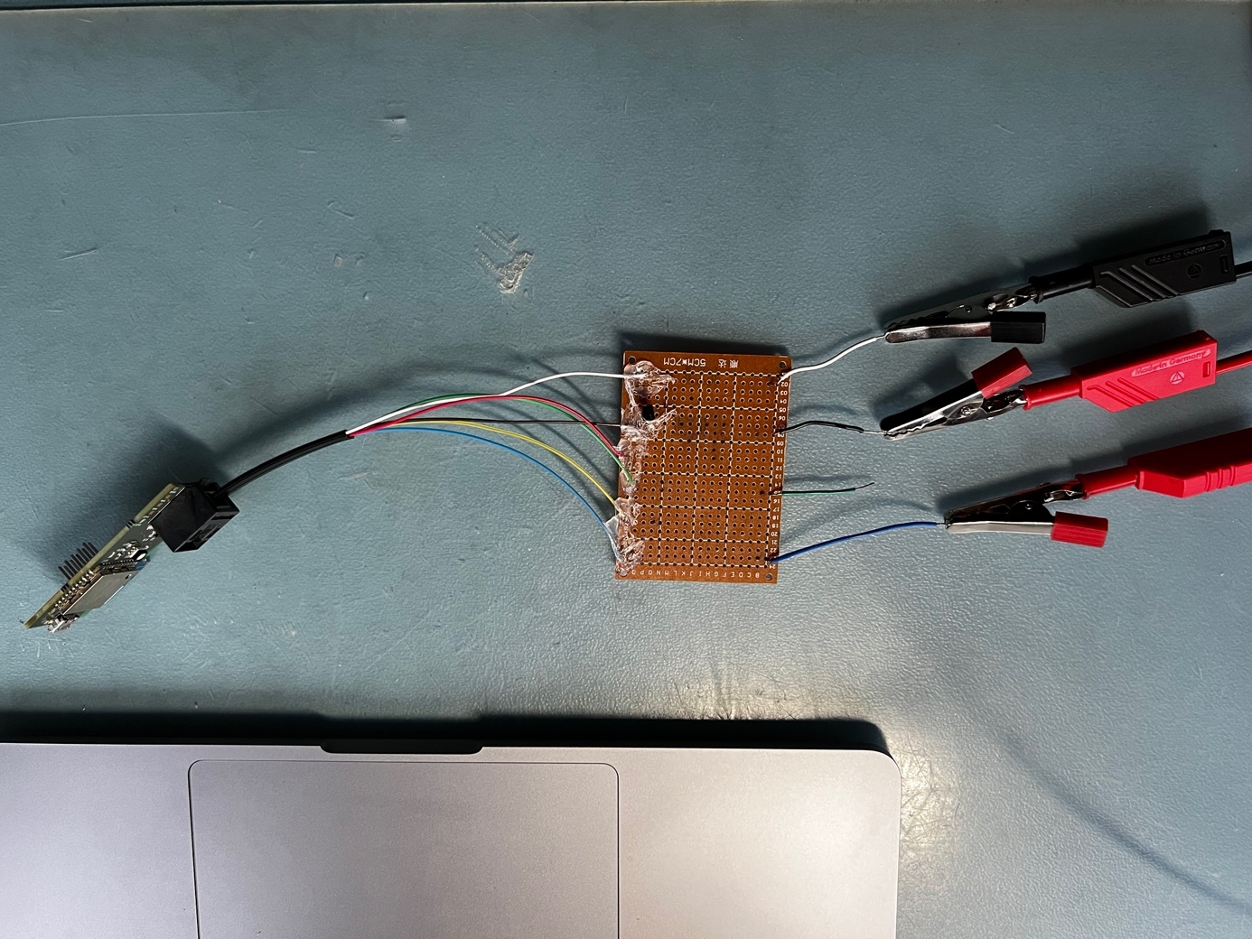

Figure 48

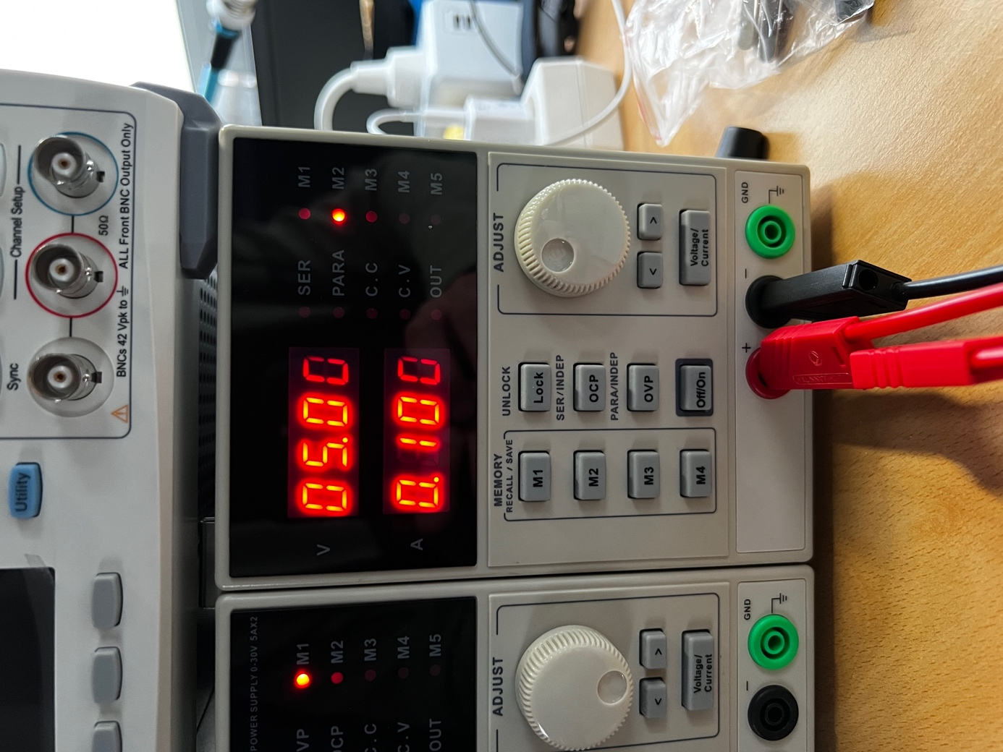

Figure 49

Figure 48 and Figure 49 show the test setup.

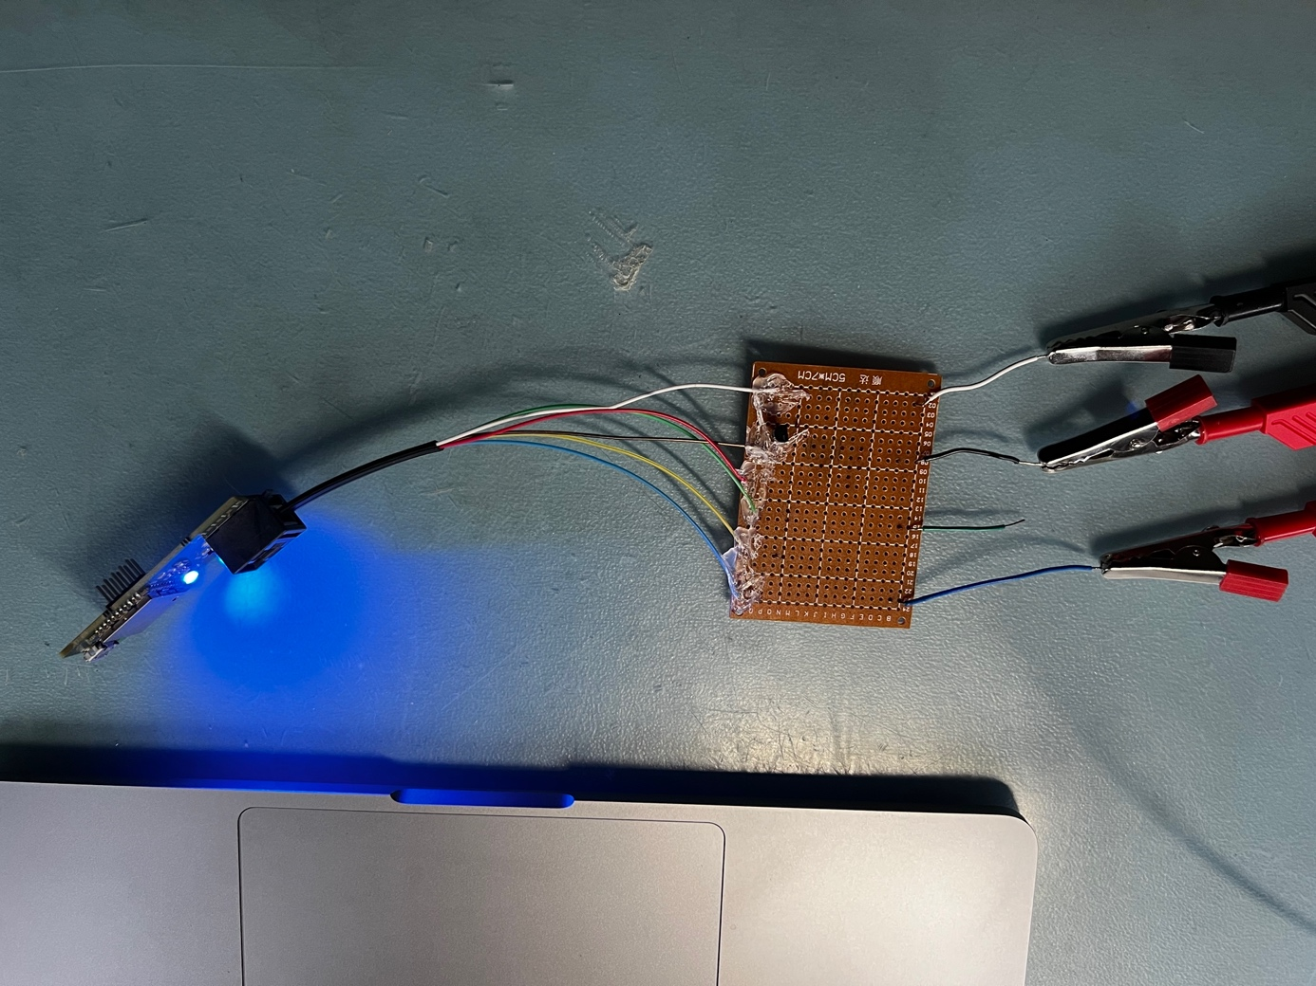

Figure 50

Figure 50 shows the result when the power was turned on. The blue LED is on, so the test is successful.

## 7.3 Test 3:

### 7.3.1 Execution test 3:

|  |  |
| --- | --- |
| Requirement(s) | * REQ-4: The product may use a maximum current of 100mA. * REQ-7: The product must be able to work with smart meters based on Dutch Smart Meter Requirements (DSMR) 5, 4 and 2. |
| Necessities | * Custom P1 port test connection * Micro USB-cable * Power bank * Multimeter * Smartphone with NRF connect app installed * RJ12 cable with interrupted +5V power wire * A long green and red banana cable with alligator clips. |
| Test Input | As test input, the signal and power from the P1 port of the smart meter and the power from a power bank are required. |
| Test Output | As test output, the blue LED is expected to light up and a connection of the final product with the phone is expected. |
| Steps | 1. Plug the RJ12 cable with interrupted +5V power wire into the final product. 2. Set the multimeter to the mA setting. 3. Plug the red banana cable with red banana clip into the input port of the multimeter. 4. Plug the green banana cable with black banana clip into the com port of the multimeter. 5. Connect the red alligator clip to the blue wire of the interrupted RJ12 cable farthest from the finished product. 6. Connect the black alligator clip to the blue wire of the interrupted RJ12 cable closest to the finished product. 7. Plug the other end of the RJ12 cable into the P1 port of the smart meter. Does the blue LED light up? 8. Check the multimeter to see if the current stays below 100mA. 9. Check in the NRF connect app whether a connection can be made with the final product. If so, is data also coming in? 10. Remove the alligator clips, the blue lamp will turn off because the finished product will no longer be powered. 11. Plug the micro-USB cable into the power bank and turn on the power bank. 12. Plug the other end of the micro-USB cable into the finished product. Will the blue lamp light up again and is it possible to connect via the NRF connect app again? |
| Completed | This test is completed when after executing step 8 a current consumption of less than 100mA is shown on the multimeter and when after executing step 12 the blue LED lights up and a connection can be made with the NRF connect app on the smartphone to the final product. |

Figure 51

### 7.3.2 Result test 3:

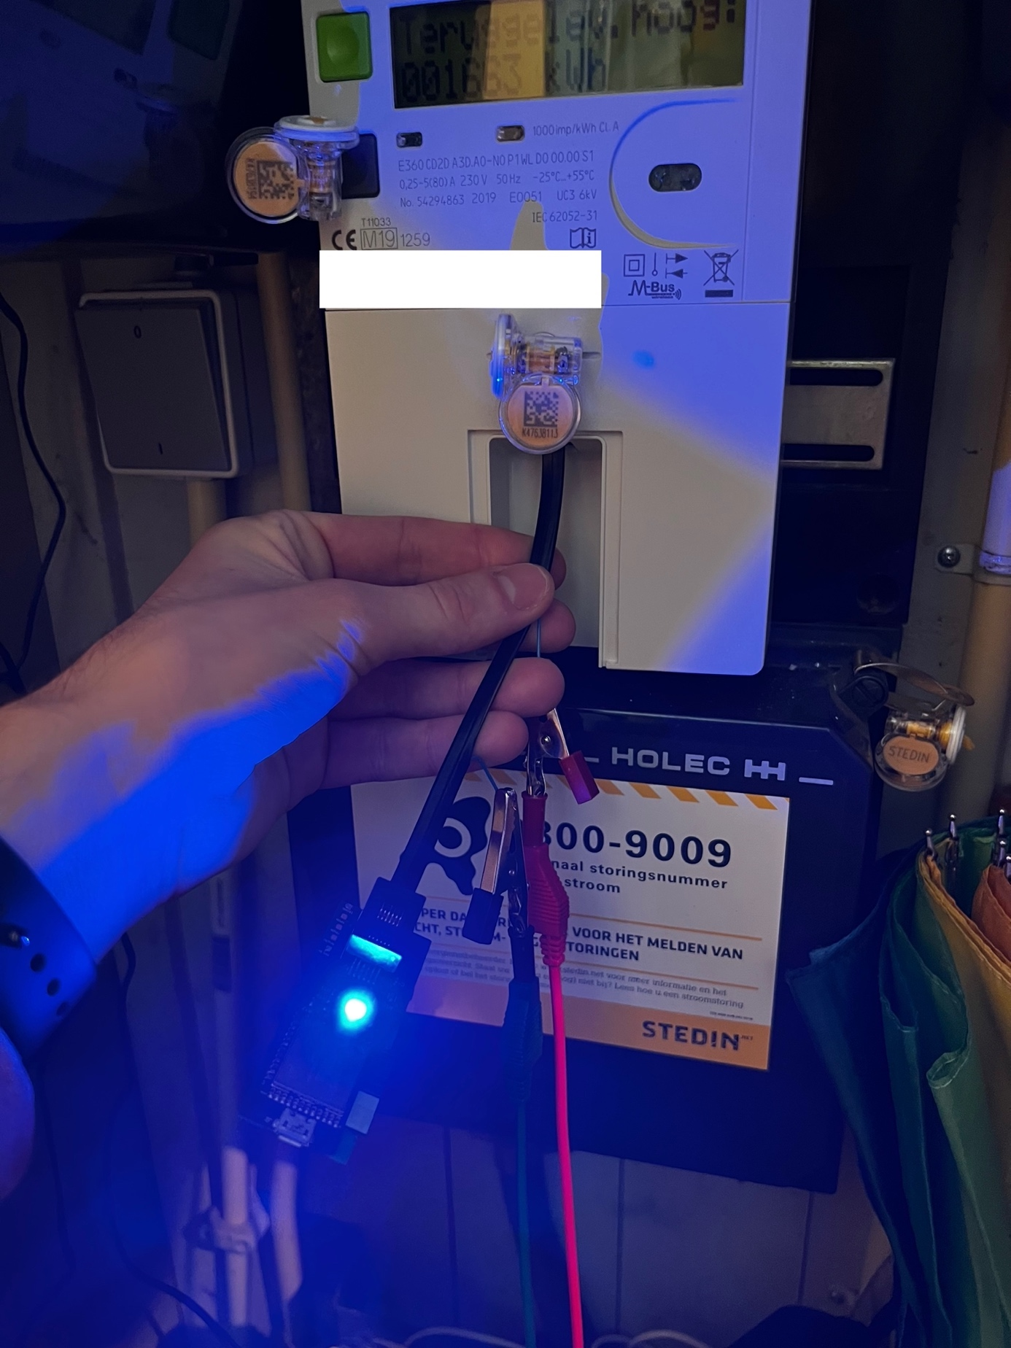

Figure 52

Figure 52 shows the test connection.

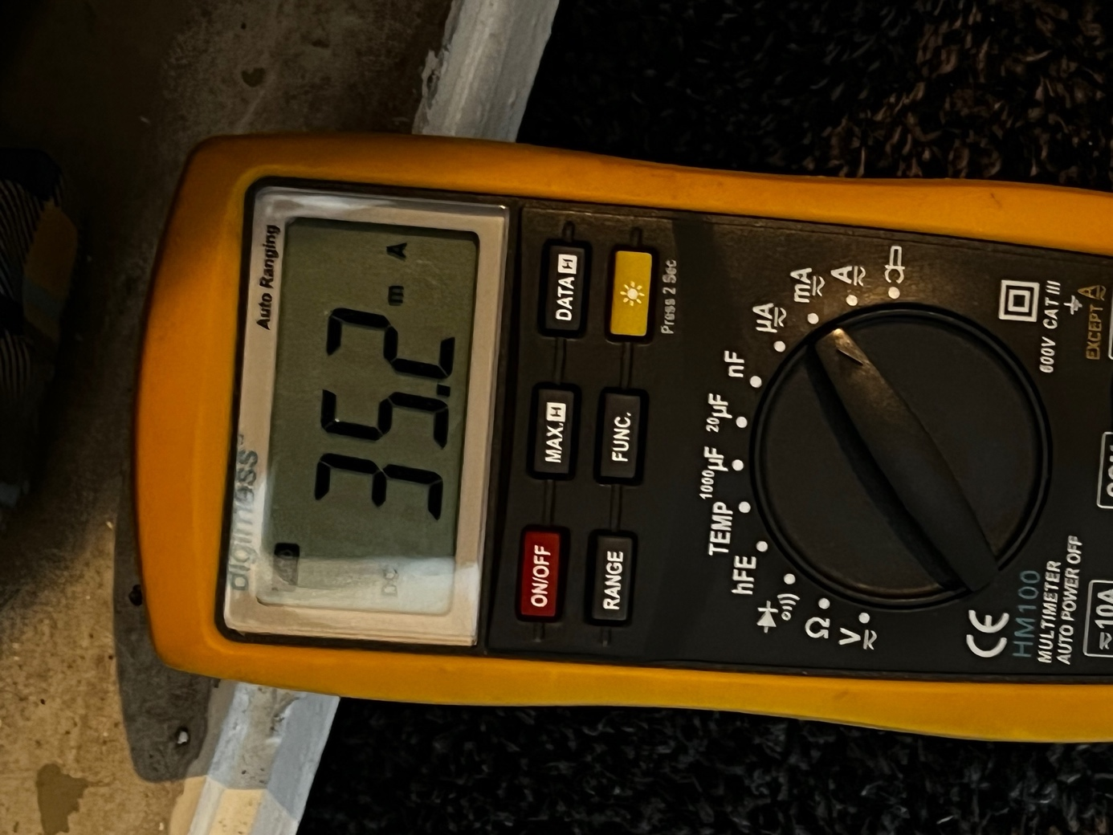

Figure 53

Figure 53 shows the image on the multimeter after performing steps 1 to 7. The multimeter indicates a current draw of 35mA. This current was measured when the blue LED was lit as brightly as possible. This LED currently provides the greatest power consumption, so the power consumption could be further reduced via software. In any case, this part of the test is successful.

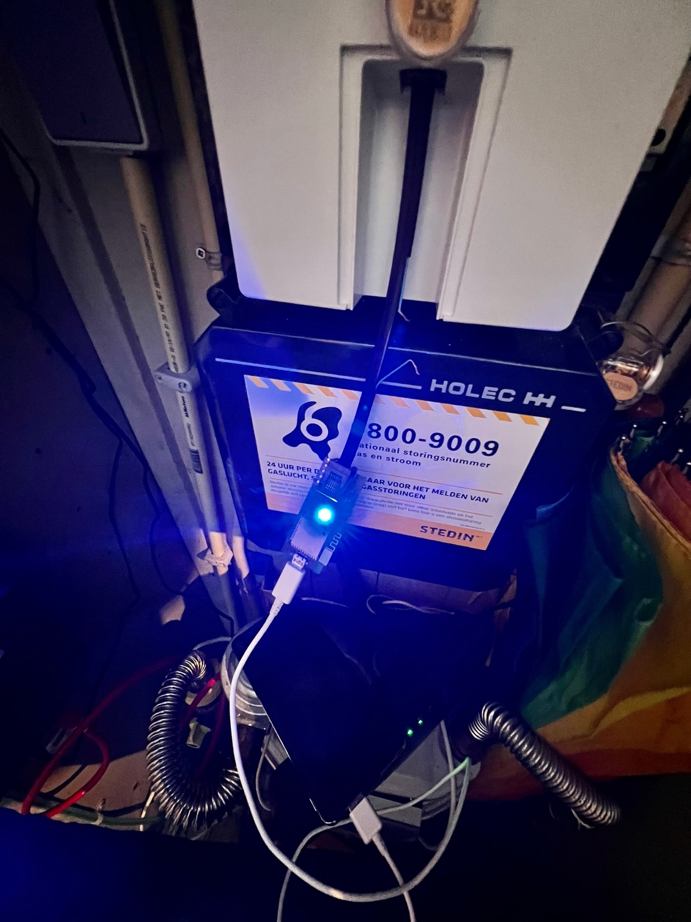

Figure 54

Figure 54 shows the test connection after performing steps 10 to 12. The blue lamp lights up again, so the final product also appears to be working properly by receiving power from the micro-USB port.

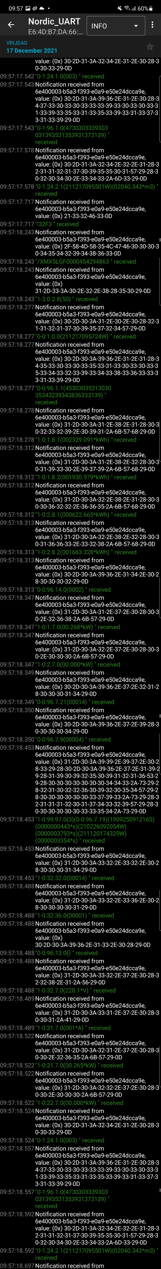

Figure 55

Figure 55 shows the image after connecting to the phone after the final product is powered through the micro-USB port. This is also as it should be, so the entire test passed.

7.4 Test 4

### 7.4.1 Execution test 4:

|  |  |
| --- | --- |
| Requirement(s) | * REQ-3: The current power and gas consumption data should be sent via Bluetooth as soon as it is received from the P1 port. * REQ-5: The consumption of several phases (if present) must be sent individually, the total consumption can then be easily calculated on a connected device. * REQ-6: A timestamp is sent at the beginning of the message from the P1 port. This must be sent by the product. |
| Necessities | * RJ12 cable * Smartphone with the NRF connect and NRF logger app installed |
| Test Input | As test input, the signal and power from the P1 port is required. |
| Test Output | The minimum test output are the following OBIS reference codes: 0-0:1.0.0 (time stamp), 1-0:1.7.0 (Actual electricity power delivered), 1-0:2.7.0 (Actual electricity power received), 1-0:21.7.0 (Instantaneous active power L1 (+P) in W resolution), 0-n:24.2.1 (Last 5-minute value (temperature converted), gas delivered to client in m3). |
| Steps | 1. Plug the RJ12 cable into the finished product. 2. Plug the other side of the RJ12 cable into the P1 port of the smart meter. 3. Open the NRF connect app on the phone, connect to the final product and enable message receiving in the NRF connect app. 4. Open the NRF logger and see if new messages are continuously posted here. 5. Take a screenshot from the beginning of the “Header information” message to the next “Header information” message. |
| Completed | The test is complete when all reference codes mentioned in test output are shown in the screenshot. |

Figure 56

### 7.4.2 Result test 4:

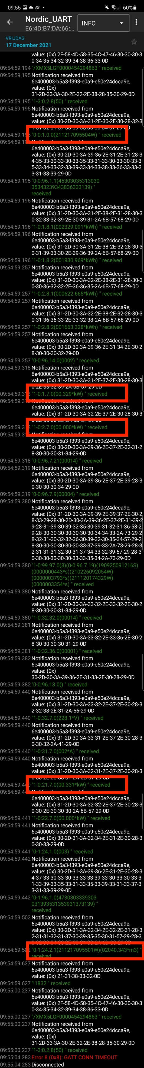

Figure 57

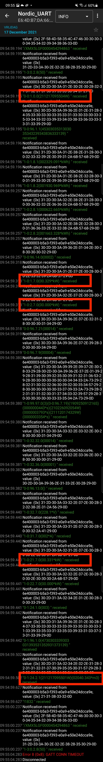

Figure 58

Figure 57 and Figure 58 show the complete message received. The aforementioned reference codes are indicated here with red boxes. The first outlined reference code (0-0:1.0.0) indicates the timestamp, so REQ-6 is satisfied. The second to last outlined reference code (1-0:21.7.0) indicates the power received from one phase. Because only one phase is connected to this smart meter, only information about that one phase is sent. If more phases were connected, the information about those phases would also be sent individually, so REQ-5 is satisfied. The other outlined reference codes indicate from top to bottom the total power supplied 1-0:1.7.0 (Actual electricity power delivered), received power 1-0:2.7.0 (Actual electricity power received) and gas consumption 0-n:24.2.1 (Last 5-minute value (temperature converted), gas delivered to client in m3) as seen from the energy supplier. All information is received and with that also the minimum required information to comply with REQ-3. This test is successful.

# Bibliography

|  |  |
| --- | --- |
| [1] | N. Nederland, "DSMR 5.0 datasheet," 26 2 2016. [Online]. Available: https://www.netbeheernederland.nl/_upload/Files/Slimme_meter_15_a727fce1f1.pdf. |
| [2] | N. Nederland, "DSMR 4.2 datasheet," 26 6 2016. [Online]. Available: https://www.netbeheernederland.nl/_upload/Files/Slimme_meter_15_32ffe3cc38.pdf. [Accessed 23 9 2021]. |
| [3] | Mouser, "Molex 95501-6669," [Online]. Available: https://nl.mouser.com/ProductDetail/Molex/95501-6669?qs=KUIzHt%2Fe91nGEpACmwALwA%3D%3D. [Accessed 10 2021]. |
| [4] | Mouser, "Wurth Elektronik 615006138421," [Online]. Available: https://nl.mouser.com/ProductDetail/Wurth-Elektronik/615006138421?qs=%2Fha2pyFadujj32eJSvwd96mjsVJIrVCf3X%252Bcq5wyxRXzJV5GuWtcNQ%3D%3D&utm_source=octopart&utm_medium=aggregator&utm_campaign=710-615006138421&utm_content=Wurth%20Elektronik. [Accessed 10 2021]. |
| [5] | Mouser, "Texas Instruments TLV9101IDBVR," [Online]. Available: https://nl.mouser.com/ProductDetail/Texas-Instruments/TLV9101IDBVR?qs=P1JMDcb91o6ZLUyc%2FHtrGA%3D%3D. [Accessed 10 2021]. |
| [6] | Mouser, "Texas Instruments TPS7A2533DRVR," [Online]. Available: https://nl.mouser.com/ProductDetail/Texas-Instruments/TPS7A2533DRVR?qs=OTrKUuiFdkbvIrFjA0rssQ%3D%3D. [Accessed 10 2021]. |
| [7] | Mouser, "STMicroelectronics LDFM33PVR," [Online]. Available: https://nl.mouser.com/ProductDetail/STMicroelectronics/LDFM33PVR?qs=qzCNEk%252BRr%252Bbt5RX7rWJkeQ%3D%3D. [Accessed 10 2021]. |
| [8] | Mouser, "Microchip Technology MCP1755S-3302E/MC," [Online]. Available: https://nl.mouser.com/ProductDetail/Microchip/MCP1755S-3302E-MC?qs=sGAEpiMZZMuJrIgwi0BoMQbLBoHfcpNhYdWDeXGWgfs%3D. [Accessed 10 2021]. |
| [9] | Raytac, "MDBT42Q-512KV2," [Online]. Available: https://www.raytac.com/product/ins.php?index_id=31. [Accessed 10 2021]. |
| [10] | Aconno, "ACN52832," [Online]. Available: https://aconno.de/products/acn52832/. [Accessed 10 2021]. |
| [11] | Nordic Semi, "3rd party modules/modems," [Online]. Available: https://www.nordicsemi.com/Nordic-Partners/3rd-party-modules. [Accessed 14 9 2021]. |
| [12] | Lumileds, "LUXEON MultiColor Module 0.5W," Mouser, 2019. [Online]. Available: https://nl.mouser.com/datasheet/2/602/Lumileds-03-14-2019-DS242_LUXEON_Multicolor_Module-1626919.pdf. [Accessed 11 10 2021]. |
| [13] | DomoticX, "P1 poort slimme meter (hardware)," [Online]. Available: http://domoticx.com/p1-poort-slimme-meter-hardware/. [Accessed 1 9 2021]. |